With Reformers Sidelined, Iranian Elections Looking Like Hard-Liners Vs. Conservatives
January 26, 2020 09:35 GMT By Golnaz Esfandiari

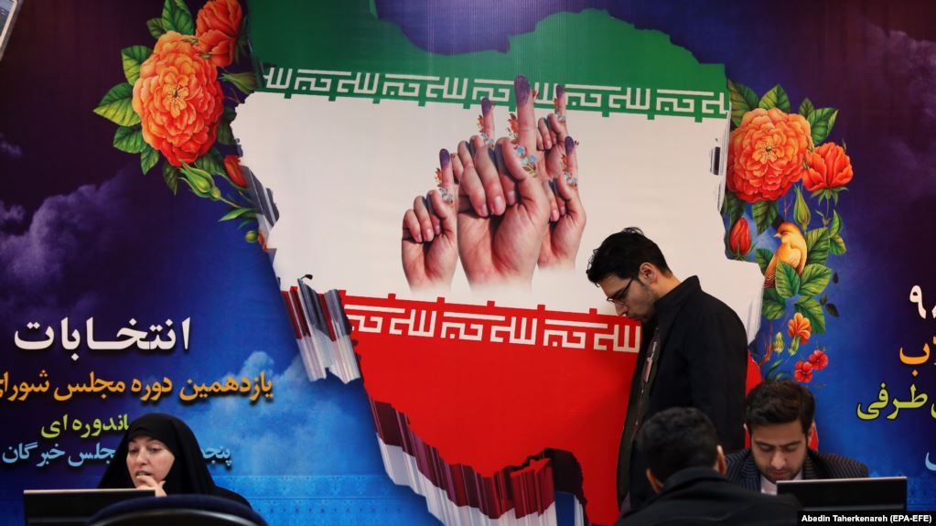
Iranians register for the February parliamentary elections at the Interior Ministry in Tehran in December.

With Iranian parliamentary elections just a month away, there are increasing signs that the vote will be a case of the conservatives battling hard-liners, in what analysts describe as an attempt by the clerical establishment to consolidate power.
The hard-line Guardians Council, which vets all election candidates, has disqualified some 9,000 of the 14,000 who registered to run in the elections, including 90 current lawmakers.
A reformist political activist said this week that 90 percent of the reformist candidates throughout the country have been barred from running in the February 21 elections.
Hamid Saberian, a political deputy to the head of the reformist Consultative Party, said on January 20 that the upcoming elections will be an “intra-factional vote” due to a mass disqualification of pro-reform candidates.
"Principalists will be competing against each other," Saberian said.
Saedi Golkar, a political science professor and senior fellow for Iran policy at the Chicago Council on Global Affairs, says the mass disqualification is part of “a big plan” to consolidate power for conservatives before the likely succession of Iranian Supreme Leader Ali Khamenei, an octogenarian who has undergone surgery in recent years amid long-standing rumors he has prostate cancer.
“Day by day, we get closer to the time which the regime should choose another leader. [And to] be prepared for that, Khamenei and his wing want to make sure the parliament and the next president are on the same page with the office of the [supreme] leader, and the [Islamic Revolutionary Guards Corps],” Golkar told RFE/RL.
Exiled political activist Taghi Rahmani told RFE/RL’s Radio Farda that the 12-member Guardians Council, six of whom are directly appointed by Khamenei, is acting based on "Khamenei’s views and the kind of parliament [the Iranian leader] envisions."
Golkar says the hard-liners are planning to roll out a new generation of supporters and put them in power throughout the government.
"The most critical crisis the regime faces is competency, which the system tries to solve by homogenization of the state branches: judiciary, legislative, and executive," he added. "One has been done, and two should be achieved to not only strengthen the regime's internal cohesion but to make it more efficient and ready for the succession."
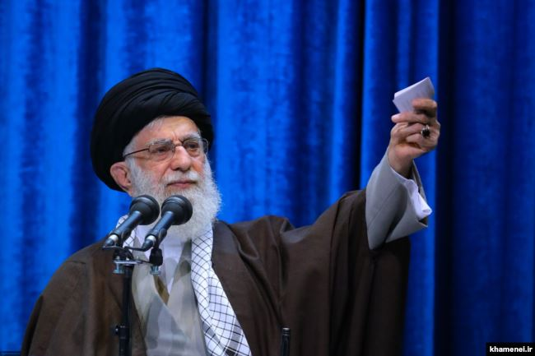
Iran's Supreme Leader Ayatollah Ali Khamenei is believed to have prostate cancer.
Abbas Ali Khadkhodayi, the spokesman for the Guardians Council, which has a record of disqualifying candidates deemed not sufficiently loyal to the clerical establishment, claimed last week that “financial abuse” and “financial crimes” are the main reasons for the disqualification of sitting parliamentarians, many of whom are reportedly reformists.
But some of the affected lawmakers have said a “lack of commitment to Islam” or "lack of commitment to the establishment” have been cited as reasons for their disqualification.
Rejected candidates can appeal decisions by the Guardians Council. In the past, only a few of those rejected have been allowed to run.
Speaking on January 15, Iranian President Hassan Rohani criticized the massive disqualifications and said it is not possible to run the country with only one political faction.
“It’s like you put 2,000 pieces of the same item in a shop...it's the same item,” he said, adding that "people want diversity."
"Allow all parties and groups to run for office," Rohani, a self-proclaimed moderate, said.
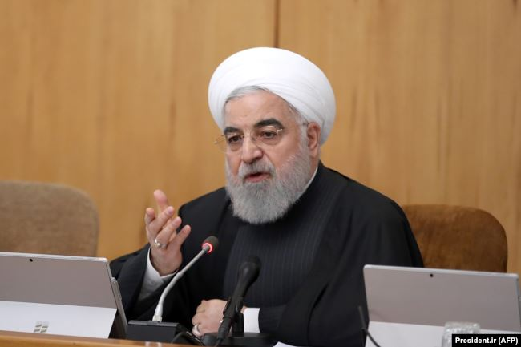
Iranian President Hassan Rohani: "Allow all parties and groups to run for office."
But Khadkhodayi has dismissed the criticism and claimed the elections will be competitive, with more than 5,000 vetted candidates running, and noted that there will be some 17 people on average competing for each of parliament’s 290 seats.
Among those who have been banned from running is reformist lawmaker Mahmud Sadeghi, who said earlier this week that “one faction” has not been able to agree on lists due to an abundance of candidates, while another faction has had so many candidates disqualified that it is struggling to come up with lists for the ballot.
"What glorious elections these will be!" the outspoken Sadeghi said sarcastically on Twitter on January 19.
Shahindokht Molaverdi, who served as Rohani’s vice president for family affairs, said “efforts are being made to uniformize the parliament.”
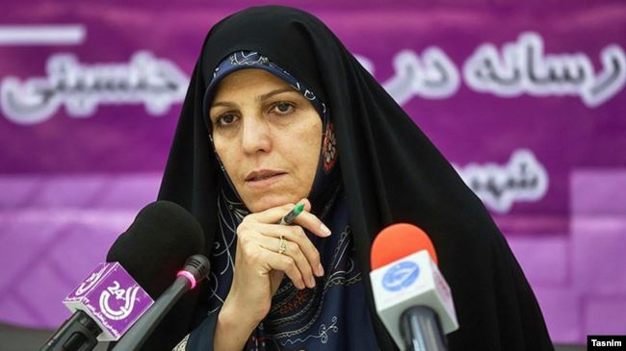
Former Vice President Shahindokht Molaverdi says she believes the decisions by the Guardians Council will alienate voters at a critical time.
Molaverdi warned that the Guardians Council’s decision will alienate Iranians at a time when the country faces external and internal pressures.
“Given the recent events and the worrying consequences of [U.S.] sanctions, it was expected that members of the Guardians Council would demonstrate a [different] approach,” she said.
Iran has faced several rounds of anti-establishment protests in past months, including in November in more than 100 cities during which several hundred protesters were killed.
The January 8 downing of a Ukrainian passenger jet by the Islamic Revolutionary Guards Corps (IRGC) that killed 176 people has also led to angry protests and calls for Khamenei to resign.
Reports suggest many Iranians have been disillusioned with the reformists due to their failure to bring meaningful changes to society. Some have said on social media that voting doesn’t make sense.
The popular news site Asriran.com said earlier this week that the election atmosphere in the country is “even colder” than the snowy winter days that Tehran and other cities have been experiencing.
Asriran said a “widespread hopelessness” and the “single-faction election” are the reasons for a lack of enthusiasm for the upcoming vote.
The current situation, the news site said, is not what Iranians who took part in the 1979 Islamic Revolution wanted.
“The people’s vote was supposed to count, not the vote of a group of people,” it added.

