Years | President | Election | Key Domestic Events | Foreign Policy Events/Issues
(1901-1905) | Roosevelt,  Theodore  (Republican)  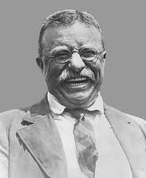
1904  (1905-1909) | Roosevelt,  Theodore  (Republican)
1908  (1909-1913) | Taft,  William (Republican)  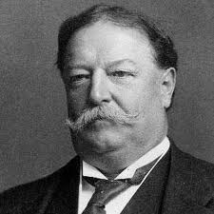

Years | President | Election | Key Domestic Events | Foreign Policy Events/Issues
1912  (1913-1917) | Wilson,  Woodrow  (Democrat)  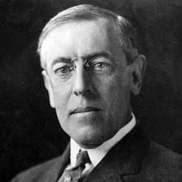
1916  (1917-1921) | Wilson,  Woodrow  (Democrat)

