The Political Heirs of Vladimir Putin
Can nepotism create the next generation of Russian leaders? The country's past century suggests it won’t be so simple.
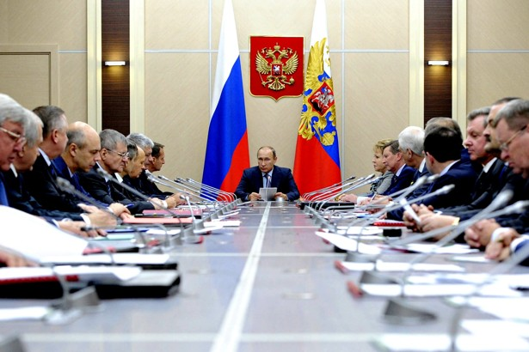
RIA Novosti / Reuters
- BRIAN WHITMORE
- NOV 13, 2015
They run banks, pension funds, and electric companies. They’re oil and gas executives. They’re worth billions. And most of them are under 40. Meet the children of Vladimir Putin’s cronies.
A new nobility is being born in Russia as Generation P—the offspring of those in Putin's inner sanctum—come of age, come into their own, and seek to inherit their parents’ power. But if the past century of Russian history is any guide, this effort to establish a hereditary aristocracy is most likely doomed.
An investigative report by Reuters this week looked closely at the emerging second generation of the Putin aristocracy. Much of it focused on Katerina Tikhonova, widely believed to be the Kremlin leader’s daughter, and her husband, Kirill Shamalov.
Tikhonova runs publicly funded projects at Moscow State University and Shamalov, the son of longtime Putin associate Nikolai Shamalov, is a top shareholder at Bank Rossia. According to Reuters, the couple is worth about $2 billion, thanks mainly to a stake in a major gas and petrochemical company that Kirill acquired from Gennady Timchenko, another Putin associate. Kirill’s brother Yury, meanwhile, is deputy chairman of Gazprombank and president of Gazfond, Russia’s largest pension fund. But Tikhonova and Shamalov are just the tip of the aristocratic iceberg.
Also among the leading heirs of the new nobility are Sergei Ivanov, son of the Kremlin chief of staff of the same name, who is director of Gazprombank, and Dmitry Patrushev, son of National Security Council Secretary Nikolai Patrushev, who heads the Russian Agricultural Bank. Igor and Roman Rotenberg, the sons of Putin’s former judo partner, Arkady Rotenberg, are respectively the majority shareholder of Gazprom Drilling and the vice president of Gazprombank. And Boris Kovalchuk, the son of Putin’s longtime friend Yury Kovalchuk, is CEO of the electricity holding InerRAO.
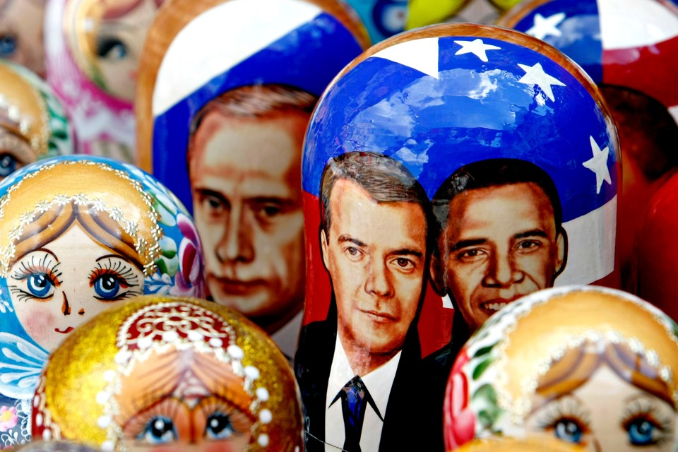
And the list goes on and on.
“Today in Russia, it is absolutely normal that the boards of directors at state banks are headed by children of security service officials, who aren’t even 30 years old when they are appointed,” the anti-corruption blogger and opposition leader Aleksei Navalny told Reuters.
“It is more than just a dynastic succession. Children don’t just inherit their parents’ posts, but also the right to choose any other post they fancy. The danger is that very soon all key resources will end up in the hands of five to seven families.”
Will the nepotism of Russia’s current rulers establish a new nobility that can take the reins of power?
Is Navalny right? Will the nepotism of Russia’s current rulers succeed in establishing a new nobility that can take the reins of power? Probably not, says opposition lawmaker Dmitry Gudkov.
“In the past century, there wasn’t a single generation of Russian elites that left power voluntarily, that wasn’t killed, supplanted, exiled, or—at best—marginalized with contempt,” Gudkov wrote recently in the business dailyVedomosti. “The elite basically resets to zero every 20-25 years, starting over with a clean slate. Before long, either red ink or blood is spilled all over that list.”
Not only have past elites been unable to pass power down to their offspring, they have often had trouble surviving themselves. Gudkov recalls how Count Vladimir Frederiks, Tsar Nicholas II’s imperial household minister, died in exile—and obscurity. Ivan Shcheglovitov and Aleksandr Protopopov, who served as chairman of the State Council and interior minister under the last tsar, were executed by the Bolsheviks in 1918.
“The elites can’t manage securing their own children’s future. Just look at the fate of the ‘Soviet nobility.’”
The old Bolsheviks who came to power in 1917 were wiped out in Stalin’s Great Terror. And the children?
“The elites can’t even manage the simple process of securing their own children’s future in Russia. Just look at the fate of the heirs of the ‘Soviet nobility’ and you’ll understand,” Gudkov wrote, noting that Josef Stalin’s granddaughter, Nikita Khrushchev’s son, and Leonid Brezhnev’s niece all live abroad. So does the daughter of Brezhnev-era ideologist Mikhail Suslov. “And these are the stories that turned out happiest.”
Ironically, Gudkov argues, it is in democratic systems that political dynasties are more stable and enduring—and leaders can retire in peace and leave the reins of power to a new generation. Authoritarian systems tend to have a problem with succession. Such regimes appear rock-solid right up until the moment they fall. And sadly, they are often replaced by something exactly the same, just with new faces.
There are exceptions, of course, most notably China, which limits its leaders to two five-year terms.
But Putin and his cohorts appear to “think they’re to Russia what the Kims are to North Korea,” Gudkov writes. “I’m sure every generation of self-appointed gods thinks, this time, things will last forever.”

