The new school rules

The academies programme has transformed England’s educational landscape
Oct 11th 2014 | From the print edition

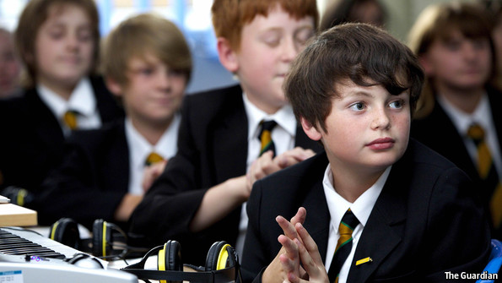
THE King Solomon Academy, a squat modern building overshadowed by social-housing tower blocks in central London, feels like the kind of inner-city school that reformers dream of creating. The mood is attentive, the walls festooned with quotes enjoining pupils to aim high.
The school, set up in 2007, is run by ARK, one of the charities, regulated by the government, that are reshaping English education. King Solomon says it wants to be “transformational” and, so far, it has succeeded. Fully 93% of the school’s 16-year-olds gained five good pass grades in core subjects in their GCSE exams this year, compared with 64% in the capital as a whole, even though three-fifths of its pupils come from homes with low incomes.
The Conservative-Liberal Democrat coalition came to power aiming to improve England’s dismal showing in global education rankings (it came 26th in the recent maths-centred round of PISA tests run by the OECD). It swiftly embarked on a mission to expand the conversion of state schools into so-called academies. The last Labour government began the project in 2002, creating non-selective schools financed from the public purse but outside the control of local authorities, which for decades had presided over a patchy system of state secondary schools, known as comprehensives.
It is uphill work. A country that funds education quite generously (13% of government spending, in the top third of outlays on schools in the developed world) lags far behind Asian high-performers such as South Korea, Japan and Hong Kong as well as improvers closer to home, such as Germany, which in the past decade has reversed its poor performance.
Under Michael Gove, a reformist education secretary, the coalition sought to speed up reforms, boosting the number of academies to about 4,000, almost 20 times as many as in 2010. That means about two-thirds of all English secondary schools now control their own staffing, curriculum and budgets. Mr Gove also created 250 free schools, with another 112 pending: usually new startups, set up by parents or community groups, with the same freedoms as academies but often smaller in scale. (Scotland and Wales have stayed aloof from the experiment, wary of the more fragmented educational landscape they fear it creates.)
The reforms have shown commendable vim, compared with the halting overhauls of other major public services such as health and welfare. An “unprecedented change in England’s schools” is under way, says Stephen Machin, an economics professor at University College London. But with a general election due in May 2015, nervousness about the impact of the upheaval is apparent. In July the prime minister abruptly replaced the combative Mr Gove (who called opponents of his reforms “the blob”). His replacement, Nicky Morgan, has struck a more soothing tone. She has gone out of her way to express commitment to raising standards across the entire spectrum of schools. It is, however, the success of academies that will determine how impressive the coalition’s reforms look to voters next May.
The dash for more autonomy has quickly created two varieties of academy. In 2010 all 203 academies were sponsored by businesses, religious groups or charities, and mainly set up to replace under-performing schools. Most of the more recent converters, by contrast, have not benefited from the external guidance of sponsors, whether individuals, other schools or charitable foundations. Instead, they are trying to change directly from being council-run schools to academies—a harder task.
On the up
The good news for the reformers is that, where academies are well-run, the results vindicate the argument for greater freedoms. Two new pieces of research, tracking pupils from schools which converted to academies before 2010, suggest that more freedoms for those who run schools can indeed raise results for both richer pupils and those from less well-off backgrounds (an important point, since many opponents on the left fret that academies attract middle-class parents and neglect the less privileged).
A report entitled “Chain Effect” for the Sutton Trust, which promotes social mobility, found that in the five leading academy chains, the proportion of poor pupils achieving five good GCSEs is at least 15 percentage points higher than the average for similar pupils in non-academy schools.
A separate study by Professor Machin and Andrew Eyles at the London School of Economics identified “beneficial effects” in schools becoming academies. Rates of improvement were also faster for more autonomous schools than for general secondary schools, and the biggest improvements were in schools converting from comprehensives, rather than from other types, such as church schools. “Autonomy”, the authors conclude, “effectively acts to facilitate school improvement.” Additional research shows that 43% of pupils entitled to free school meals in comprehensives that did not convert to the academy model gained five good GCSEs. That rose to 45% in those that did convert—a small increase, but achieved rapidly.
Half-full or half-empty?
Alas, this promising picture describes only about half of the schools set free from local authorities. There are strikingly large differences in the performances of academy chains. One, the E-ACT chain which ran over 30 schools, was ordered to hand ten back to central government control earlier this year. Sir David Bell, the most senior civil servant in charge of the school reforms in 2007-10, now vice-chancellor of Reading University, thinks larger chains can acquire some of the same problems that local authorities had, “being too big to have oversight over what happens in individual schools and too bureaucratic”. Hopes that big providers might offer consistent quality at scale have faded, to be replaced by an acknowledgment that keeping chains small or medium-sized may prove more reliable.
Supporters of academies want to see the best chains expand, driving out bad ones. In practice this can be painfully slow, because the best chains tend to expand prudently rather than rush to create empires. Liam Nolan, who heads the Perry Beeches network of six academies and free schools around Birmingham, says he favours “close-knit families of schools” in geographically close areas, where staff can be swapped around or moved to more senior jobs within the group. Mr Nolan thinks success is achieved by “spreading an ethos as well as technical teaching tips”. But this leaves post-Gove reformers wondering how to sustain a rapid pace of reform without compromising on quality.
This tension runs through school reforms in many countries. Germany, for example, is struggling to apply to other areas the changes it made to secondary education in Saxony, which closed poorly performing schools. A number of lessons from America’s best charter schools (a forerunner of academies) might help. A study of the most successful ones by Roland Fryer of Harvard University found that the quality of school heads was closely monitored and underperformers were quickly ousted. Longer school days improved literacy and numeracy, especially among the less able. Performance data—still erratically used in English schools—were deployed to track pupils’ progress.
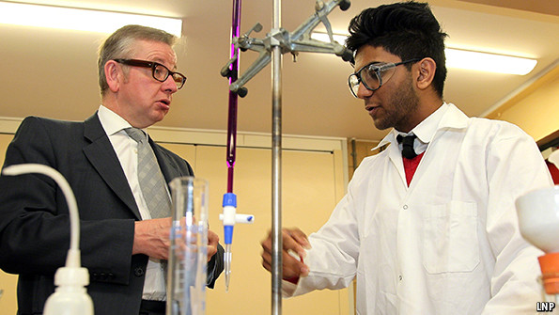
The standard of inspectorates also matters. Sweden’s free-school movement, for instance, was let down by poor follow-up from inspectors. Sir Michael Wilshaw, head of Ofsted, the British government’s schools watchdog, has fought for more powers to examine academy chains—an overdue step.
Meanwhile the fate of the free-school programme looks less certain. The coalition’s reformers hoped they would boost innovation by allowing parents or community groups to start schools. Few doubt that the momentum driving the creation of new free schools will falter if Labour, which is cool about the experiment, is elected in May, so many potential founders are rushing in their applications now. And even with the present government’s backing, free schools represent a mere 4% of the total number of schools in 2014, rising to around 6% by 2015.
One reason the government talks less enthusiastically about free schools than it did is that they can cause headaches over accountability. In one dramatic example, the Muslim al-Madinah free school in the city of Derby closed this year after complaints of fundamentalist proselytising, intimidation of non-Muslim staff and poor teaching. The saga suggests that badly run schools can decline more quickly than national inspectors can monitor. Attempts to agree upon a middle tier of local accountability that does not involve handing power back to local authorities have been fraught.
The words of the non-profits
But accountability is not the same as momentum, and some believe the best way to turbocharge the reforms would be to allow for-profit operators into the mix. Toby Young, a journalist who became one of the first free-school founders in London, argues that such a move would overcome regulatory and bureaucratic obstacles. Allowing for-profit chains to operate (as in America and Sweden) might well help expand the limited pool of people willing to start new schools. Allowing only non-profit groups to become new providers has encouraged the overexpansion of some chains, often with little competition. Ms Morgan says that she would like to revisit the argument, though she freely admits that “most people wouldn’t like it”.
One interim solution is to encourage other successful academic institutions to oversee academies. Birmingham University is launching an academy, which will also train new teachers. University College London has created a specialist science school. The private sector is also being encouraged to sponsor more academies; Wellington College, a leading private school, has added a primary school to the secondary school it already runs.
For all the gripes about academies, often from vested interests (notably teachers’ unions) who prefer the state to dominate the provision of education, England’s secondary-education system has adapted quickly to new freedoms. It needs to use more of them, driving out weaker heads and teachers and finding quicker ways of exposing and fixing failures. Yet a tour of the country’s new breed of schools is, on the whole, an uplifting experience. It shows a more diverse system, one more firmly focused on improvement.
One lesson stands out: the culture of achievement, especially in literacy, has to be instilled before children reach their stroppy, secondary-school years. So fixing education should start younger, with more academies, like King Solomon, taking pupils from the age of three up to 18. For all their flaws and failings, the new schools have injected something exciting into a once-moribund education landscape: the belief that regardless of wealth or background, schools can transform lives.

