The fog of wars

Adventures abroad boost public support at home
Oct 22nd 2016 | From the print edition

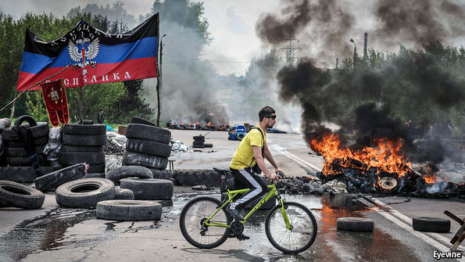
RUSSIA HAS NO intention of going to war with America or its allies. Instead it will act through non-military means “to undermine the general political and strategic potential of major Western powers, to disrupt national self-confidence, to increase social and industrial unrest, to stimulate all forms of disunity…Anti-British talk will be plugged among Americans, anti-American talk among British. Germans will be taught to abhor both Anglo-Saxon powers. Where suspicions exist, they will be fanned; where not, ignited.” So wrote George Kennan, the “wise man” of American diplomacy, in a famous telegram from Moscow in 1946. Seventy years later the telegram seems as relevant as ever, because the system that Kennan described is being rebuilt.
Russia has launched cyber-attacks, spread disinformation and interfered in the domestic affairs of both neighbouring and faraway countries. Its military jets are buzzing NATO’s ships and flying close to American reconnaissance aircraft in Europe. The American government has formally accused Russia of meddling in the presidential election by means of extensive hacking. In Syria it has subverted America’s efforts to defeat Bashar al-Assad and threatened to shoot down American warplanes if they attack his army.
The BND, Germany’s foreign-intelligence agency, is investigating Russian activity in Germany after Russia’s state television ran a fake story about a 13-year-old Russian-German girl being raped by Arab immigrants in Berlin. Spread through social media, the story sparked protests against Angela Merkel, the German chancellor.
Russia has provided funds for the French right-wing party of Marine Le Pen. RT, the Kremlin’s foreign-language propaganda TV channel, has offered a regular spot to Nigel Farage, the former leader of Britain’s far-right UKIP party. Russia’s support for Donald Trump, the Republican presidential candidate, who has also appeared on RT, has become a talking-point in America’s forthcoming election.
None of this is particularly new. Subversion, disinformation and forgery, combined with the use of special forces, were at the heart of the Soviet Union’s intelligence services. The KGB had a special department responsible for “active measures”, designed to weaken and undermine the West. It stirred racial tension by posting bogus letters from the Ku Klux Klan, planted stories about AIDS having been invented in America as a biological weapon and put it about that John F. Kennedy’s murder was plotted by the CIA.
Yuri Andropov, the head of the KGB in the 1970s and one of Mr Putin’s heroes, set up special courses to train operatives in the use of active measures. At the height of the cold war 15,000 officers were working on psychological and disinformation warfare. When the Soviet Union collapsed, the department was renamed but never dismantled.
Modern technology has helped it widen its scope; the Kremlin now uses large numbers of “trolls” that spread disinformation and propaganda through online communities and social media. It also helps Russia to sow confusion by putting out multiple versions of events. According to Alexander Vershbow, NATO’s deputy secretary-general and a former American ambassador to Moscow, it is “an endlessly changing storyline designed to obfuscate and confuse to create the impression that there are no reliable facts, and therefore no truth.”
This echoes Kennan’s observation in 1946 that “the very disrespect of Russians for objective truth—indeed, their disbelief in its existence—leads them to view all stated facts as instruments for furtherance of one ulterior purpose or another.” Unlike Soviet propaganda, which aimed to promote communist ideology, modern Russian propaganda aims to show that Western policies are as rigged and hypocritical as Russian ones.
Assessing the effectiveness of these Russian attempts to influence opinion abroad is hard because they often tap into existing sentiments, from disenchantment with elites to resentment of immigrants. But research by Finland’s Institute of International Affairs has found that Russian propaganda has had very little impact on mainstream Western media and has never resulted in any change in policy. A strong and confident West should find it easy to brush off Russian media assaults. But sober political thinkers have noted some signs of a “Putin panic” in the West, and Mr Putin himself has said that America’s attempts to present Russia as an “evil empire” indicates “Russia’s growing influence and significance”.
In the eyes of his own people, Mr Putin has restored his country’s status to that of the Soviet Union. According to a recent report by the Aleksanteri Institute in Finland, a think-tank, “the West’s response to the Crimea annexation partially did exactly what Putin had demanded: putting forward the notion of Western weakness in the face of Russia’s superior ‘hybrid warfare’ capabilities implies respect and even fear of Russia as a powerful global actor.”
The country’s intervention in Syria in the autumn of last year was designed to reinforce the image of Russia as a global power. It did change the course of events, saving Bashar al-Assad from a seemingly inevitable fall, and made the humanitarian situation in Syria far worse. But Russia cares little about the future of Syria. It sees the war there as a way of forcing America to recognise a Russian sphere of influence in the former Soviet Union.
Weakness in strength
The wars in Ukraine, Georgia and Syria have demonstrated Russia’s willingness and ability to use its military power to achieve political goals. But they are not a sign of Russia’s strength; instead, they indicate deep insecurity. As Kennan wrote: “At [the] bottom of [the] Kremlin’s neurotic view of world affairs is [the] traditional and instinctive Russian sense of insecurity…This thesis provides justification for that increase of the military and police power of the Russian state…Basically this is only the steady advance of uneasy Russian nationalism, a centuries-old movement in which conceptions of offence and defence are inextricably confused.” This nationalism continues to shape Russia’s behaviour today.
Mr Putin sees Russia’s wars as a form of self-defence, driven by the need to deter the West. That is what he meant when he gathered the country’s elite in the Kremlin’s gilded hall to announce Russia’s “reunification” with Crimea on March 18th 2014. “Like a mirror, the situation in Ukraine reflects what has been happening in the world over the past several decades. Our Western partners, led by the United States of America, prefer not to be guided by international law but by the rule of the gun.” In Ukraine, he said, the West had crossed a red line. Western actions left Russia with no choice but to send its troops into Crimea.
Yet only a few days earlier Mr Putin had told the German chancellor, Angela Merkel, that there were no Russian troops in Crimea. “He lives in another world,” she was reported to have said to Barack Obama. In his world the West was trying to undermine Russia. The colour revolutions across the former Soviet Union and the protests in Russia in the winter of 2011-12 were Western plots.
Yet his view of the West as a threat was not, as many have argued, his starting position; it developed in response to changes inside Russia and the former Soviet republics. When Mr Putin became president in 2000, he showed no overt hostility towards America or the West, despite a recent NATO bombing raid on Belgrade without a UN resolution that had triggered a shrill anti-American response. In his first interview with Britain’s BBC, Mr Putin said: “I cannot imagine my own country in isolation from Europe, so it is hard for me to visualise NATO as an enemy.” Russia, he said, might become a member of NATO if it were treated as an equal partner. Even when the three Baltic states joined NATO in spring 2004, Mr Putin insisted that relations with the defence organisation were “developing positively” and he had “no concerns about the expansion of NATO”.
The breaking-point in Mr Putin’s relationship with the West came towards the end of that year when several seemingly unrelated events coincided. The first was a terrorist attack on a school in Beslan, in the north Causasus, in which 1,200 people, mostly children, were taken hostage. After Russia’s special forces stormed the school, leaving 333 people dead, Mr Putin accused the West of trying to undermine Russia. He cancelled regional elections and handed more powers to the security services.
The next key event was the dismemberment and expropriation of the Yukos oil firm, which further emboldened and enriched the siloviki with roots in the Soviet KGB. They thrived on the idea of a Western conspiracy and an exaggerated sense of the West as an enemy.
The call of liberty
Just such an enemy was provided by the Orange revolution in Ukraine in 2004-05, a popular uprising against rigged presidential elections in which Mr Putin had backed Viktor Yanukovych, a corrupt thug. His defeat at that time (he was elected later) was seen as a humiliation for the Kremlin and an ominous sign of American meddling, underlined by George W. Bush’s praise for democracy in Georgia and Ukraine and his comment that “eventually the call of liberty comes to every mind and every soul.” Mr Putin saw Georgia’s successful reforms and its determination to break out of the post-Soviet system and move towards the West as a threat, in the same way as the Soviet Union had felt threatened by liberal reforms in Czechoslovakia in 1968. And just as the Kremlin had responded by ordering tanks into Prague to stop the reforms spreading to the Soviet Union, so Russia sent its tanks and planes into Georgia in August 2008. Immediately after that war Mr Putin ordered a thorough modernisation of the Russian armed forces.
America chose to follow the war in Georgia with a “reset” initiated by the new Democratic president, Mr Obama, and his secretary of state, Hillary Clinton. But when protests broke out in 2011-12 Mr Putin accused Mrs Clinton of spurring protesters on: “She set the tone for some actors in our country and gave them a signal…They heard the signal and with the support of the US State Department began active work.” As Ms Hill and Mr Gaddy wrote, “America and Europe encourage political and economic change as a matter of course in their foreign policies. The essence of Western political systems extends to promoting democracy and liberal markets abroad.” But whereas Western governments see such efforts as benign, Mr Putin considers them a danger, they continue: “Western-style democracy and open markets are a clear threat to a Russian political system that thrives as a closed one-body network and an economic protection racket.” In Russia’s new military doctrine, signed by Mr Putin at the end of 2014, popular uprisings against an oppressive regime were classified as a military aggression which warrants a military response.
In January 2013 Valery Gerasimov, then newly appointed as chief of staff, had spoken about a new type of warfare that Russia had to face. “The emphasis in methods of struggle is shifting towards widespread use of political, economic, informational, humanitarian and other non-military measures…Overt use of force, often under the guise of peacekeeping and crisis management, occurs only at a certain stage, primarily to achieve definitive success in the conflict.” The revolution in Kiev in the winter of 2013-14 which overthrew Viktor Yanukovych was perceived by the Kremlin as an escalation of hostilities by “hybrid means”.
Russia’s heavy propaganda campaign which portrayed Ukraine’s post-revolutionary government as fascists paved the way for its own special forces in Crimea, allowing them to stage a coup, overthrow the legitimate government and appoint its placemen who quickly called an unconstitutional referendum on joining Russia. In Mr Putin’s mind, Russia’s actions in Crimea and eastern Ukraine merely mirrored Western “hybrid” tactics, including special forces, disinformation and mobilisation of the protest potential of the local people. The annexation of Crimea was bloodless.
In eastern Ukraine the task was different. It was not to annex territory but to spark a conflict that would undermine Ukraine’s territorial integrity and its chances of moving towards the West. Whereas in Crimea Russia relied on a disenchanted population nostalgic for the Soviet era, in Donbas it was supported by the core of Mr Yanukovych’s voters who considered the government in Kiev illegal. But Russia’s operations in both Crimea and eastern Ukraine were limited in scale and depended on a power vacuum in Kiev. As Alexander Nevzorov, a Russian journalist, wrote, “Crimea was taken not from a strong, rich and brave country but from a wounded, bleeding and motionless one.”
Samuel Charap of the International Institute for Strategic Studies notes that if Russia had attempted to deploy its “little green men” (soldiers in unmarked green uniforms) in Western Ukraine, for example, “they would have likely been hanging from the lamp-posts, not leading an armed insurgency.” Even in Donbas, Russia had to use its conventional military force to stop the Ukrainian army from defeating the Russian-armed rebels. Russia’s Ukraine operation, therefore, should not be seen as a template for a potential conflict with NATO, Mr Charap argues.
Belarus, another Slavic, Russian-speaking country that was one of the founding members of the Soviet Union, could also be a target. It is ruled by Alexander Lukashenko, often called the last dictator in Europe, and so far Russia has kept him going with its gas subsidies. But should the Kremlin sense that Mr Lukashenko’s grip is weakening or that he is turning towards the West, it could easily stage a coup and take the place over.
The perception of Russia’s military advantage rests on two main elements, argues Alexander Golts, a Russian military analyst. One is unpredictability and surprise, because Mr Putin is not constrained by any formal institutions or by his own team. The other is Russia’s ability quickly to deploy well-trained, disciplined and equipped troops, thanks to the modernisation of its forces enabled by a 30% increase in spending in real terms since 2008. Russia has about 80,000 elite troops that can be sent into battle within hours.
Russia’s conventional military expansion is limited by its demography. According to its own estimates, this year it will be able to increase its forces by only 10,000 men, barely enough for one division. It also needs to be careful to minimise casualties, which go down badly with a population that sees war as a television show. The number of people who supported Russia’s military invasion in Ukraine declined from 47% in June 2014 to 25% a year later, according to the Levada Centre.
The nuclear option
Russia’s military-industrial complex is unable to produce anything close to Soviet volumes of hardware. But the country’s relative economic and military weakness compared with NATO does not make the country any safer; on the contrary, it poses a big risk. The only way Russia can compensate for the gaps in its conventional forces is to invoke the threat of a nuclear strike. After the annexation of Crimea Mr Putin said he had been ready to use nuclear arms to defend his country’s “historic territory”. And after Russia showed off its long-range cruise missiles in Syria, Mr Putin said that it was prepared to use its powerful weapons if its national interests were infringed upon, implying that those missiles might one day carry nuclear warheads. America’s “impudent behaviour” would have “nuclear consequences”, said one of Mr Putin’s chief propagandists.
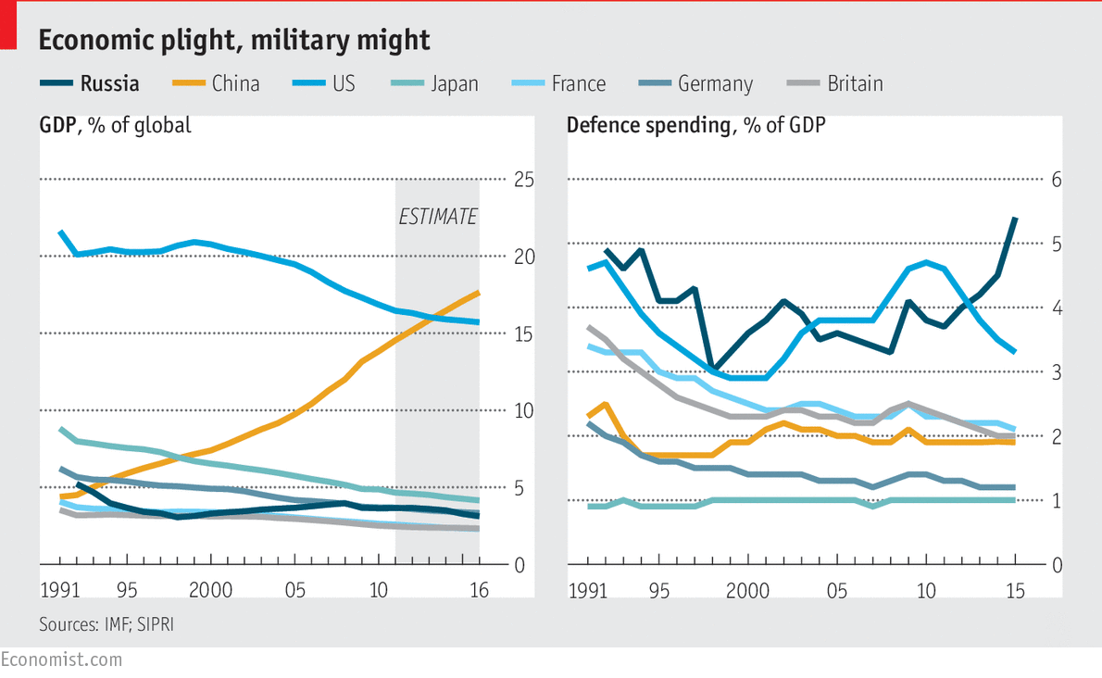
After Stalin’s death the Soviet Union was ruled by a generation of leaders who, having emerged as victors from the second world war, were naturally averse to another big war and genuinely fearful of the use of nuclear arms. They were also restrained by the collective power of the Politburo, which had ousted Nikita Khrushchev soon after he dragged the Soviet Union into the Cuban missile crisis.
Mr Putin, on the other hand, is bound by few constraints and has no particular aversion to war. His initial popularity as president rested on the war he had waged against Chechnya in 1999, and his sagging ratings were restored by the war in Ukraine.
Yet Mr Putin would not unleash a war for ideological reasons. He will continue to present his actions as defensive. What he is ultimately after is a new pact along the lines of the Yalta agreement after the second world war which would create a buffer zone between Russia and the West. In the absence of such a deal, Mr Putin will continue to confront his perceived enemies by both non-military and military means. Western sanctions only reinforce his determination.
Mr Putin has no plans to conquer the world. He may be impervious to logic or reason, but he is highly sensitive to force. He knows he cannot afford a conventional war with the West, but he could quickly raise the stakes to the verge of a nuclear war, believing that the other side would always blink first. Over the past 16 years the West has done little to persuade him otherwise.

