My Culture Project
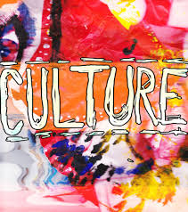
Create an exhibition that reflects your culture! This project should have color and should have some 3-D components (not just pictures.) This is a 50-point grade. Students who meet the minimum expectations can expect a grade of 43 points. Students who exceed the expectations can earn up to 50 points. The project will be assessed using the following criteria.
Completeness: The exhibition illustrates at least six different characteristics of your culture. Please do not be limited to this number.
Color/Creativity: The exhibition is vivid and uses creativity to express who you are. It should have more than just pictures and words.
Neatness and Effort: The exhibition shows thoughtfulness and effort.

Here are some things you may want to include. Again, please do not be limited by these suggestions.
- Family traditions
- Holiday observances
- Hobbies centered around art or music
- Religious or philosophical foundations
- Food
- Language
- ethnicity

Please see Ms. Holley for issues concerning the project requirements and/or the gathering of materials.

