The credo: Great rejuvenation of the Chinese nation

BBC November 7, 2014

At October's top level Communist Party meeting in Beijing, President Xi Jinping set out his vision for China's governance.
There will be little space for civil society, no Western-style democracy and no listening to "well-fed foreigners who have nothing better to do than to lecture us".
Instead the message of the Plenum is that President Xi wants a rules-based system in which a cleaned-up and competent Party/state bureaucracy continues to serve the "masses" unchallenged.
Kleptocratic dictatorships which call themselves democratic are not thereby democratic. And the same applies to political parties which call themselves communist.
The Chinese Communist Party is an entrenched ruling party whose guiding ideology is not Marxism but national "rejuvenation" and whose leader is now unashamedly reaching back to the language of his imperial forbears to unite his 1.3bn citizens.
It would be easier for the world to understand if the Chinese Communist Party were to rename itself the Chinese Nationalist Party, but awkwardly that's the bunch the communists swept from power 65 years ago, so the name is forever off limits.
Make no mistake though. Xi Jinping is a nationalist leader with a nationalist credo.
In power for two years already, he has a further eight to go.
The evidence suggests that Xi Jinping simply doesn't believe in Western-style liberal democracy for China
If he can reform China's economy and hold its politics together, his era may see China overtake the US as the world's largest economy in absolute terms (it has just overtaken the US on the measure which takes account of differences in the cost of living).
And by the time he leaves office in 2022, China may have built its own space station and assembled the military might to confront US strategic resolve in Asia.
This is exactly what Xi Jinping means by "the great rejuvenation of the Chinese nation".
But for China's "great rejuvenation" to succeed depends now on the success of enormously challenging economic reform, and that in turn depends on the resilience and flexibility of its politics.

Special country
So what are Xi Jinping's politics?
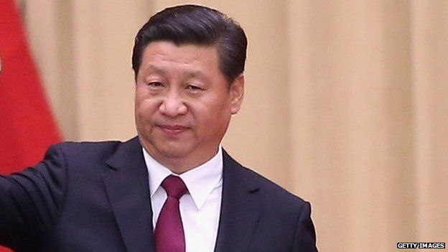Image captionXi is not a fan of Western-style democracy
President Xi believes that China is special and different. As he puts it: "Several thousand years ago, the Chinese nation trod a path that was different from other nations."
Two years into his leadership, the fond hope cherished by some dissidents and Western observers that he might be a closet liberal has been completely dashed.
Since the US and China restored relations in 1979, successive US governments have argued that exposure to capitalism and globalisation would eventually bind China into the existing world order and advance the political freedoms that underpin it.
But Xi Jinping has made it clear he has no time for either. Instead he is determined to make China's internal politics fit for a very different world order.
And he is a more confident and purposeful leader than China has seen at the top since Mao Zedong or Deng Xiaoping.
The evidence suggests that Xi Jinping simply doesn't believe in Western-style liberal democracy for China.
Like many of his generation of Chinese leaders, he was dismayed by the collapse of communist rule in Moscow.
He is famously reported to have said the Soviet Union fell apart in 1991 because "no-one had the balls to stand up for it".
Observers often put this mindset of the Chinese political elite down to self-interest.
A threat to a Communist Party anywhere is a threat to the air of invincibility which helps the Chinese Communist Party stay in power.

No democracy
But even allowing for self-interest, Chinese leaders seem to believe an unchallenged ruling party is essential to national interest.
They feel the post-communist politics of Russia has offered only negative lessons.
When they look at the colour revolutions of the former Soviet Union (Rose in Georgia, Orange in Ukraine and Tulip in Kyrgistan) or survey the aftermath of the Arab Spring overthrow of dictatorships in North Africa, or the electoral experiments which followed American interventions in Iraq and Afghanistan, they see no compelling model for China to follow.
They also argue that in the reform era of the past 35 years, they have done better in meeting the needs of their 1.3 billion citizens than the world's largest democracy, India.
And the global financial crisis of 2008 and the spectacle of partisan gridlock in Washington have only increased confidence in China's brand mix of authoritarianism and nationalism.
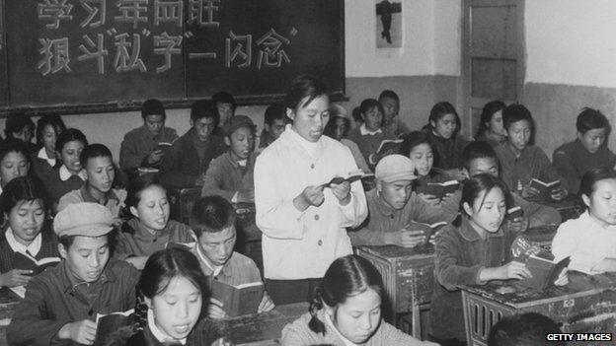Image captionThe 1949 Communist revolution ushered in an era of authoritarianism
During a visit to Europe earlier this year, President Xi observed: "Constitutional monarchy, imperial restoration, parliamentarism, a multi-party system and a presidential system, we considered them, tried them, but none worked."
He was referring to the period between the 1911 revolution which toppled China's last imperial dynasty and the 1949 Communist revolution.
He explained that China could not copy the politics of other countries "because it would not fit us and it might even lead to catastrophic consequences".
If not democracy, then what?
In the past month, the umbrella movement in Hong Kong has spectacularly reopened this question.
China's propaganda machine has worked hard to close it down again in the usual way, portraying the protest as the work of foreign hostile forces intent on stirring up "colour revolution" on Chinese soil.
But even the president of Taiwan Ma Ying-jeou urged Beijing to think again, arguing that democracy is not a western monopoly but a universal value, and warning that as China becomes more prosperous, its people will want more democracy.
China, he said, should "let some people go democratic first".
On many issues, Beijing sees President Ma as a friend of China, which makes it hard to dismiss him as just another "colour revolutionary".

Widespread censorship
But on the mainland, discussion of universal values is censored, along with civil society, citizen rights, judicial independence and freedom of the press.
In fact, one notable feature of Xi Jinping's politics is to close down the number of people who are allowed to discuss politics.
He is laying claim to an enduring and authentically Chinese tradition
In the two years since he came to power, the red lines for dissent have shifted, the space for any alternative discourse has narrowed.
Many lawyers and academics who were once tolerated, even encouraged, are now in jail.
At a forum for writers and artists in October, Mr Xi made a point of applauding the work of a blogger famous for championing the "China dream" in contrast to the "broken American dream".
The politics of the China dream: a rejuvenated authoritarianism.
Mr Xi is determined to make his ruling party fit to rule.
He has embarked on the boldest anti-corruption campaign in communist history.
He is also not ashamed of being an authoritarian.
Sensing that there is no return to the idealism and sense of shared purpose of the revolutionary years, he has avoided the language of the 1950s.
Instead he is reaching further back to a public service philosophy that has its roots in the mandarin culture of the imperial civil service. Mr Xi talks of the need to "recover new things from Chinese history and culture so that it has greater cohesive force and greater influence on the minds of Chinese people".

Complex history
For thousands of years, China's political philosophers have distilled lessons from the rich history of governing this vast and complex country.
The early communists rejected that legacy wholesale.
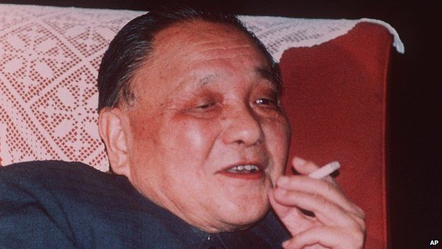Image captionXi is thought to be the most confident leader since Deng Xiaoping
But Mr Xi quotes liberally from Confucius and the rest, firmly cloaking himself in the patriarchal language of his imperial ancestors to cement the legitimacy of authoritarian rule.
He is laying claim to an enduring and authentically Chinese tradition.
"We in the Communist Party are firm Marxists," he has said.
"At the same time, we… cannot be ignorant of the history of our own country, and we cannot belittle ourselves.
"As Chinese people have more engagement with the outside world, they have a deeper need for self-affirmation."
Can a 21st Century China, a global power with a mobile and connected citizenry, find the answers to the challenges of of its future by closing down discussion and uniting around the playbook from its past?
This is what President Xi intends.
Certainly he is working hard at being the confident father to the nation, developing an image which is much less constrained and technocratic than his immediate predecessors.
Worth noting too the recent publication of a book of his political philosophy, Xi Jinping: The governance of China.
And almost all the proposals approved for social science research funding this year deal with the thought of Xi Jinping.
The politics of the Xi years: personality cult, nationhood and going back to China's past to shape its future.
But that recipe didn't cure the problems of the 20th Century, and the 21st is only going to be more complex. Xi Jinping may yet need revisions to his "governance of China".

