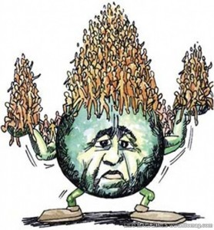
Agendas APHUG September 24 & 26, 2019

September 24
- AMSCO Quiz
- Discussion
- Population Simulation- using candy, the students will simulate the factors involved in demographic changes.
- Where are the Lights- in groups, students will answer questions concerning demographic changes using maps provided by NASA.

September 26
- EBs: Mahood, Mann, Meridith
D’Ippolito, Edwards, Graovac

- Population Pyramid Questions

- Models: Each students will build two population pyramids- one for each of their selected countries. The models will represent current trends. The students will also create two one-page papers that reflect population trends in each country. This should include CBR, CDR, IMR, emigration, immigration, and internal migration. The paper should also include a very brief description of the model.

