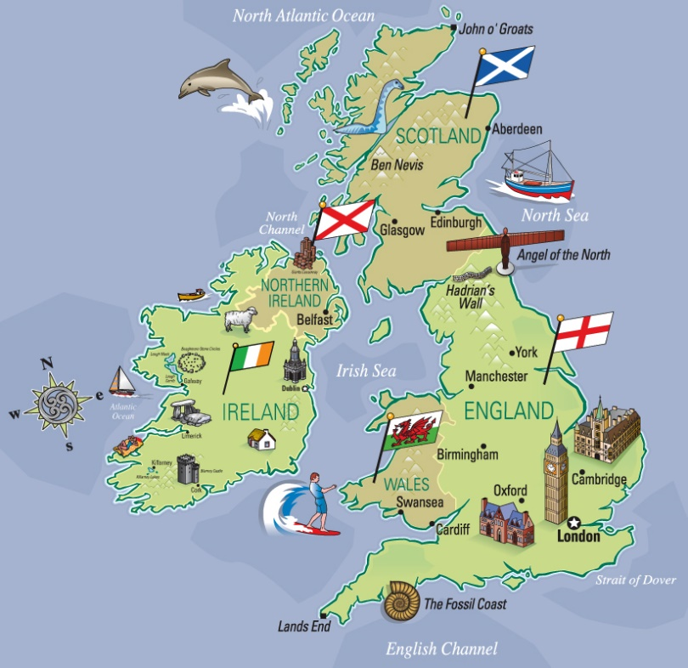
APCOGO September
23-27, 2019
September 23
- EBs: Hanna, Hawver
Elswick, Flores
DeLuca, Fling

- Lecture

September 25
- Quiz: Allah’s England, Unique Faces, Legacy

- EBs: Jeram, Le
Hains, Johnson
Hewett, Holley

September 27
FRQ Practice- UK

