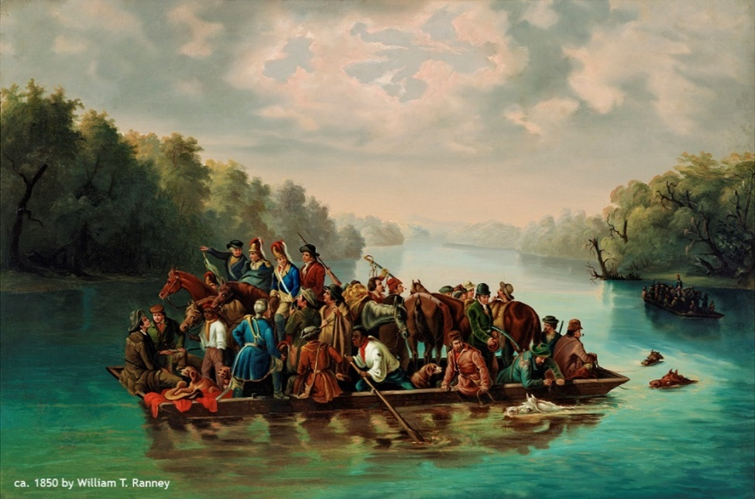
September
23-27
2019
September 23
Students will complete the Boston Massacre document analysis independently.

September 24
- As a class, analyze the portrait of Francis Marion crossing the Pee Dee River.
- Lecture: Causes of the Revolution

September 25

- AMSCO 4 & 5
- Reconcile or Rumble
- Each student will be assigned a small portion of one of two speeches concerning independence.
- After reading their portion, students will work in groups to compile arguments in favor or against independence.
- Each side will present their evidence.
- Students will individually create a meme either in favor or against independence

September 26

Students will complete the Reconcile or Rumble activity.

September 27
America: The Story of US- Revolution

