APHUG September 17 & 19, 2019

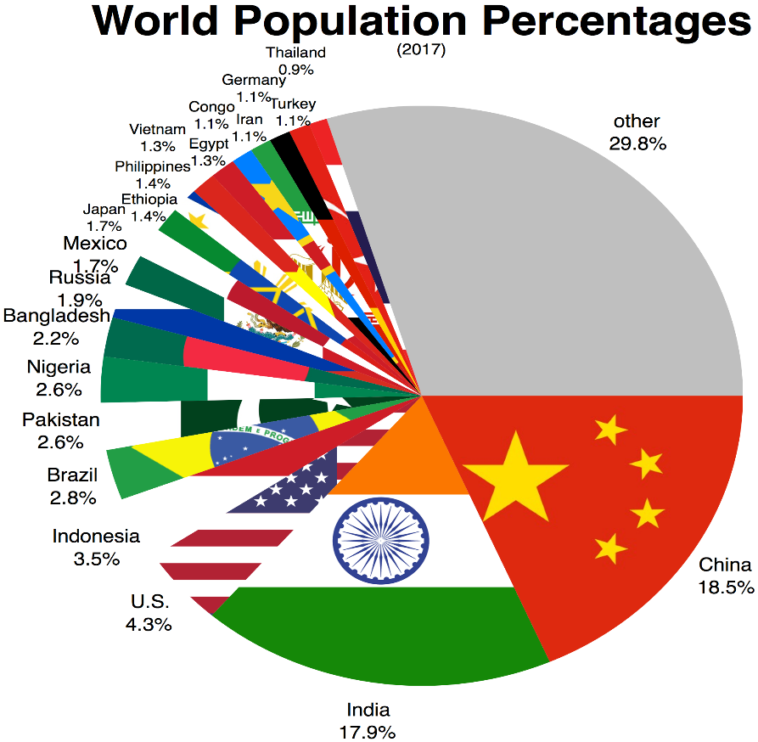

September 17
TEST

September 19
- Map Test

- EBs: Banning, Clement, Kellogg
Bao, Best, Carter

- Population Density Simulation

