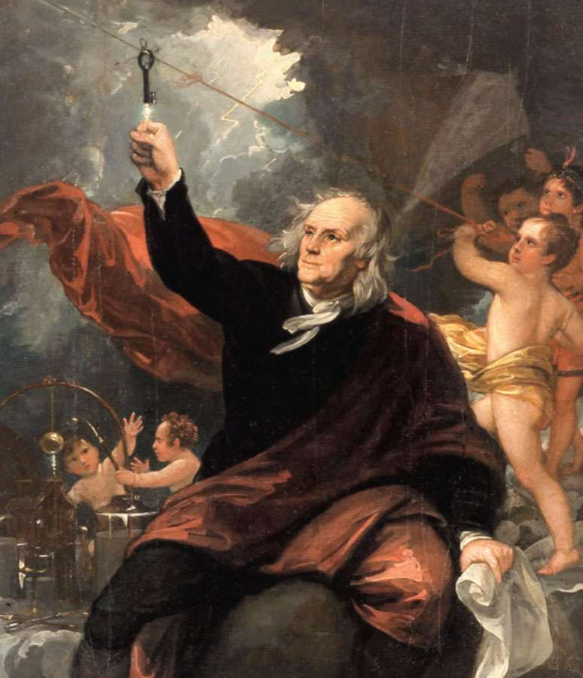
APUSH
September 16-20
2019

September 16
- Complete Document Analysis
- Complete Period 2 Progress check on AP Classroom.

September 17
Lecture: 18th Century America

September 18
Great Awakening Lesson
- Ms. Holley will give a brief overview of the Enlightenment and of the Great Awakening.
- Each student will take on the role of a reporter in colonial America.
- They will walk around the room and “experience” several different sermons from the G.A., taking notes as they go.
- Once all students have visited each station, in pairs they will discuss their findings.

September 19
TEST

September 20
Road to Revolution: Cause/Effect Chart

