RUSSIAN POLICY PROJECT
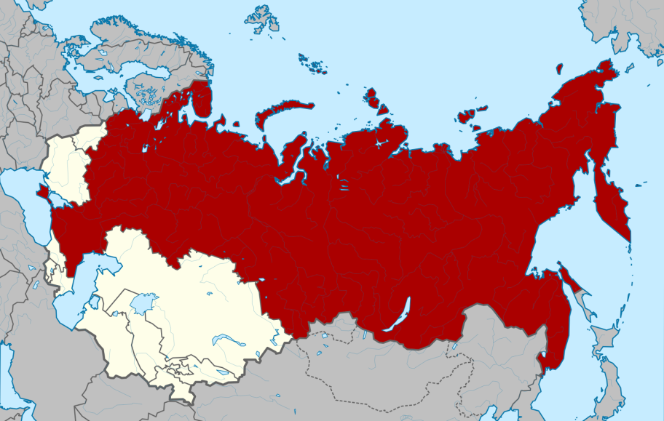

Objective: Students will research the backgrounds, formations, and ramifications of various policy spheres in order to determine the current trajectory of domestic and foreign policy issues in Russia.

Select one of the following policy issues in Russia. Research the problems/issues that created the policy need, identify the laws or actions that were developed, and explore the ramifications of the enforcement of the policies. Include, in your presentation, your opinion on the policy and its enactment.

Create a visual presentation using Piktochart or Powtoon. Publish on

Digital Project Ideas:
- Create Pikochart that gives
Create a Powtoon that

