Putin’s Nightmare: The Ballot Box
On the eve of regional elections, the Kremlin has turned to tricks, threats and shows of force to get past the shadows of protests and falling approval ratings for Russia’s president.
By Michael Khodarkovsky
Professor Khodarkovsky is the author, most recently, of “Russia’s 20th Century: A Journey in 100 Histories.”
- Sept. 3, 2019

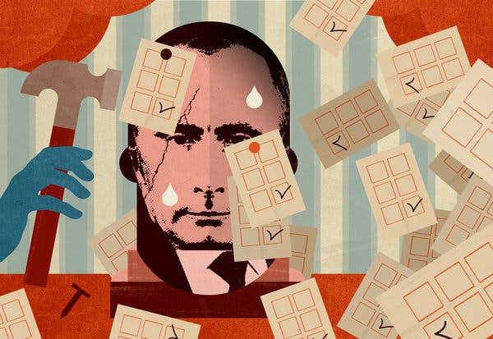
CreditCreditChristina Hägerfors
On Sept. 8, Russians will vote in municipal and regional elections, and the authorities are afraid. Not of any foreign power’s interference in Russia’s elections — there have been no fair elections in decades — but of Russia’s own people and opposition candidates, who are far more popular than the official nominees.
Moscow’s old bag of electoral tricks survives — for example, moving elections from December to early September so that summer vacations would leave challengers little time to organize. The authorities have resorted to new tricks too, like clogging the electoral system with fake candidates and putting party loyalists on the ballot as independent candidates.
This year’s election will also see a new mobile digital voting system that allows people to vote online from any location. Critics say it is yet another trick to help the authorities.
Leaving nothing to chance, Moscow’s electoral commission found bogus reasons to disqualify all unapproved candidates from running in the elections. And to intimidate those would-be candidates, their homes were raided and many of them were detained, brought to Police Headquarters and interrogated in the middle of the night.
Yet none of that worked: Thousands of people took to the streets, beginning on July 28, to protest the election committee’s decisions. In response, the authorities deployed an overwhelming force of local and federal police who detained most opposition leaders and nearly 1,400 demonstrators.
Two weeks later, when Moscow’s authorities permitted an organized meeting, some 60,000 people gathered in the streets despite government warnings and intimidation. Even though the meeting was officially sanctioned, the police used force to disperse the demonstrators and arrested hundreds. Since then, all opposition requests to allow meetings have been rejected.
The Kremlin has been sending a clear message: There will be no Hong Kong here, with its huge protests, nor any Istanbul, with its fair election that led to the opposition’s victory. And to achieve this, the Kremlin is determined to use violence on a large scale. It should surprise nobody. This is the natural evolution of an autocracy — when its public slowly turns against the regime, brute force remains the only means to stay in power.
By any measure, the decline of Putinism is indisputable. It was best captured by a poll conducted in May by the government-run Public Opinion Center, which showed that public trust in President Vladimir Putin had fallen to 25 percent. The Kremlin, which uses the center to gauge public opinion and rarely makes the results public, was furious and called for another poll. Several days later, a new poll showed that 72 percent of Russians had trust in the president. The Kremlin was happy, and the center promised “to improve its methodology.”
Then in June, after Mr. Putin’s annual Direct Line TV appearance — a question-and-answer marathon staged to present an all-knowing leader in direct communication with citizens — the channel’s YouTube site registered 12,000 likes and 170,000 dislikes. Some experts calculated Mr. Putin’s support among this audience at about 7 percent.

With the examples of Hong Kong and Istanbul perhaps on their minds, Mr. Putin and his cronies surely remember how, 30 years ago, Mikhail Gorbachev experimented with a limited free election. Previous Soviet national and regional elections had been shams, with Communist Party candidates invariably winning their posts because they faced no competitors.
Mr. Gorbachev wanted to invigorate the Soviet system by making it more competitive and allowing some nonparty members into its legislative body.
To do so, he created a new legislative body: the Congress of People’s Deputies, consisting of 2,250 delegates. One-third of the seats were reserved for Communist Party members, leaving the other two-thirds open to contest. Of course, even in the openly elected seats, the party-endorsed candidates had numerous advantages. And yet, when the election took place in March 1989, there were big surprises: 300 candidates, or about 16 percent of the new legislative body, had defeated party-endorsed candidates. Among those who lost were five Central Committee members, one member of the Politburo, and 35 regional party bosses.
Mr. Gorbachev touted the new election as a victory for his reforms and a successful effort to democratize the Soviet political system. The hard-liners, unnerved by new freedoms and unaccustomed to any political opposition, were not amused then, as they are not amused now.
One longtime Kremlin insider and an architect of Mr. Putin’s regime, Vladislav Surkov, recently declared that Russia could be maintained only as a military-police state, and that Mr. Putin was the only leader whom the Russian people could trust. Putinism, he maintained, was a new political system, and like Marxism or Leninism, would last for centuries.
Despite such wishful thinking — or posturing — at the top, Putinism has been steadily falling apart: Government-controlled media are struggling to sustain the president’s falling ratings; Russia’s regions are impoverished; the oil- and gas-dependent economy is anemic; Russia’s elites are consumed by infighting for pieces of a shrinking pie; and the young generation is less susceptible than their forebears to government propaganda.
Putinism appears destined to last a far shorter time than either Marxism or Leninism. It was conceived as a hybrid autocracy in which a ruling elite controls most of the economy and media in the name of the state, but tolerates a limited number of independent but closely watched businesses and media outlets. Unlike the Chinese Communist Party, with its total control of society, Mr. Putin’s Kremlin has chosen to leave an escape valve for dissenting opinions — as long as they remain marginal and pose no threat to those in power.
ADVERTISEMENT
But this model may have now reached its end. The opposition proved to be less marginal than the Kremlin hoped and, as dissatisfaction with the regime grew, the Kremlin decided there was no longer any usefulness in pretending that democracy ruled. The irony is that despite Moscow’s new willingness to move toward a stricter Chinese mode, it is the seriousness with which Russians took those previous grants of limited liberties that now make harsh repression necessary.
In truth, Russia has already reverted to a military-police state, keeping Mr. Putin and his regime in power mainly by force and intimidation. Not relying on police alone, the Kremlin in 2016 created a special force of 340,000 strong Russian Guards, whose mission is primarily “protecting public order.” The government has also been steadily dismantling what is left of a market economy, moving assets into the state coffers and investing in a rapidly expanding military-industrial complex.
Most of the recent mass arrests, and the brutal treatment of protesters and members of the opposition, are a clear indication that the regime is fully prepared to use violence to stay in power.
The Kremlin understands that genuine democracy would mean the end of Putinism, and so it leaves those who desire change through democratic means with no options. But does Mr. Putin really want to turn Red Square into a Russian Tiananmen Square?
Michael Khodarkovsky is a professor of history at Loyola University Chicago.

