 |  | President | Election |  | Issues
1841-1845 |  | Tyler,  John  (Whig??)  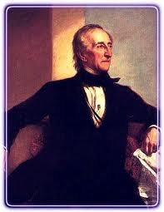
1844  1845-1849 |  | Polk, James  (Democrat)  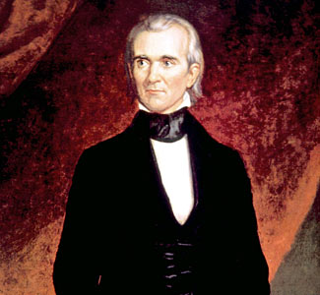
1848  1849-  1850 |  | Taylor,  Zachary.  (Whig)  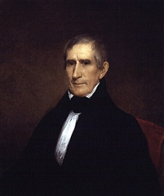
1850-1853 |  | Filmore,  Millard  (Whig)  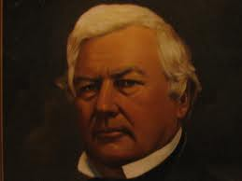
1852  1853-1857 | Pierce, Franklin  (Democrat)  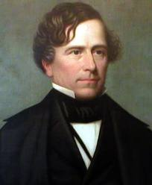
1856  1857-  1861 | Buchanan,  James  (Democrat)  