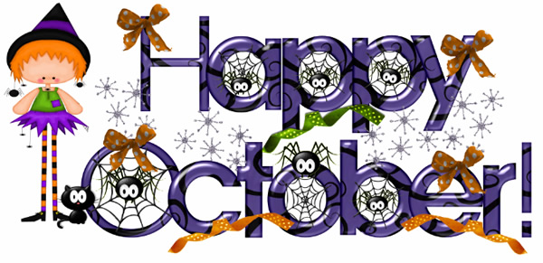
MONDAY | WEDNESDAY | FRIDAY
30 UK  New School Rules, Govt. Look | - UK  Institutions/Map Test | 4 UK
7 UK  TEST | 9 Russia  EBs: Mastroberti, Pilkey  Lackey, Renshaw, Richardson  Kellogg, Lawrence | 11 Russia  EBs: Tomlin, Truluck  Small, Stec, Wisler  Meese, Ward
14 Russia  Wood Russia | 16 Russia  PSAT | 18 Russia  15 Years, Inside Bear
21 Russia  Fog of War/ Putin’s Nightmare | 23 Russia  Institutions/ Map Test | 25 Russia  Heirs/ War on Women
28 Russia  TEST | 30 Mexico | 