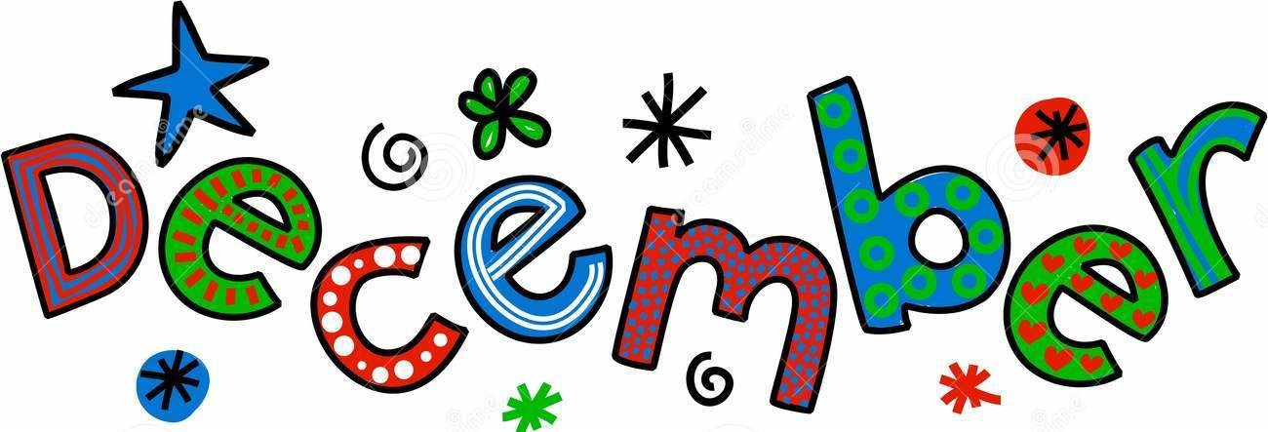

2 Nigeria | 4 Nigeria  Wood: Nigeria | 6 Nigeria  CW: Analysis of entire program  Nigeria: Pain & Promise  EBs: Doyle, Golden  Bronovitskiy, Case  Bright, Chiarovano
9 Nigeria  EBs: Hanna, Hawver  Elswick, Flores  Deluca, Fling  CW: Lecture | 11 Nigeria  EBs: Jeram, Le  Hains, Johnson  Hewitt, Holley | 13 Nigeria  EBs: Mastroberti, Pilkey  Renshaw, Richardson  Kellogg, Lawrence
16 Nigeria  HW: Map/Institution Quiz | 18 Nigeria  HW: Blood Oil  (Vanity Fair) | 