Nigeria arrests 'Avengers' oil militants
- 16 May 2016
- Share this with Facebook

- Share this with Twitter

- Share this with Messenger

- Share this with Email
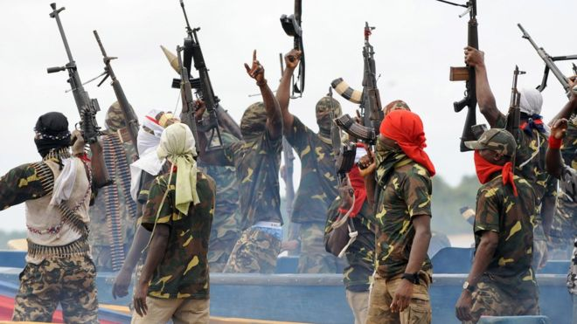Image copyrightAFPImage captionSeveral militant groups in the Niger Delta have attacked oil facilities in the past
The Nigerian army has arrested several suspected members of a militant group called the "Niger Delta Avengers" (NDA), thought to be behind recent attacks on oil pipelines in the south.
The country's oil production has been severely disrupted by the attacks.
US oil giant Chevron shut down an offshore platform this month after an attack claimed by the Avengers group.
Many militants joined an amnesty programme in 2009 after an insurgency in the oil-rich delta region.
Nigeria has long been Africa's largest oil producer, but its economy is currently facing difficulties due to the recent drop in global oil prices and its output is now behind that of Angola.
Most of Nigeria's oil wealth comes from the Niger Delta, an area which remains poor and underdeveloped.
Previous insurgent groups said they were fighting so local people could benefit more from their region's natural resources.
Oil spills have also resulted in environmental devastation over the years.

Who are the Niger Delta Avengers?
There are still very few independently confirmed details about the group, which announced its formation three months ago.
On its website, it says it is fighting for an independent state on behalf of the people of the Niger Delta and is prepared to "cripple Nigeria's economy" in pursuit of its aims.
It mocks President Muhammadu Buhari for never having visited the "creeks of the Niger Delta" and criticises him for the continued detention of Nnamdi Kanu, the leading member of a group which backs the creation of a breakaway state of Biafra in the south-east.
It boasts about its members being "young, educated, well travelled...and educated in east Europe".
Its tactic of attacking oil facilities in the region, announced in February, has caused havoc in the sector, with production levels in the country now reported to have fallen to their lowest for more than two decades.
One attack on an underwater Shell pipeline in February showed a high level of technical expertise, forcing the shutdown of a terminal which normally produces 250,000 barrels of oil a day.
Many locals suspect that some former oil militants excluded from the amnesty programme could be behind the group.
But speculation is rife and everyone has their own theory about who is to blame.
Whatever the case, the group's growing stature is a major headache for President Buhari, whose government is already grappling with Boko Haram's insurgency in the north-east.

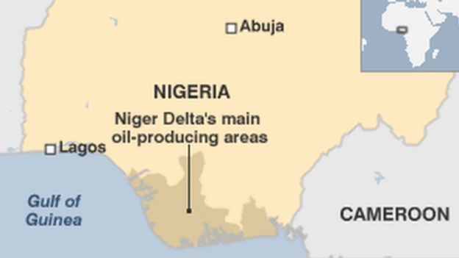Image copyrightBBC NEWS ONLINE

The amnesty programme, which provides tens of thousands of former oil militants with a monthly stipend from the government, stemmed the level of violence in the region after its introduction in 2009.
But in the latest budget, Nigerian President Muhammadu Buhari reduced fundingfor the programme by 70%, and has spoken of phasing it out entirely by 2018.
Critics accuse Mr Buhari, a Muslim northerner, of unfairly targeting communities in the southern, mainly Christian oil-producing regions, as part of his anti-corruption drive.
Mr Buhari's predecessor Goodluck Jonathan, a Christian, comes from the Niger Delta region.
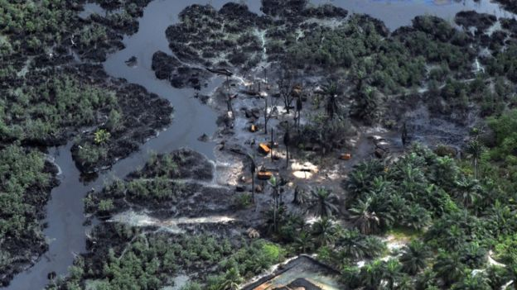Image copyrightGETTY IMAGESImage captionThere have been many catastrophic oil spills in the Niger Delta over the years

