Let Rouhani and Khamenei Fight

It’s in America’s interest for the Iranian regime’s bitter power struggle to intensify further.
By Reuel Marc Gerecht and Ray Takeyh
March 6, 2018 7:08 p.m. ET
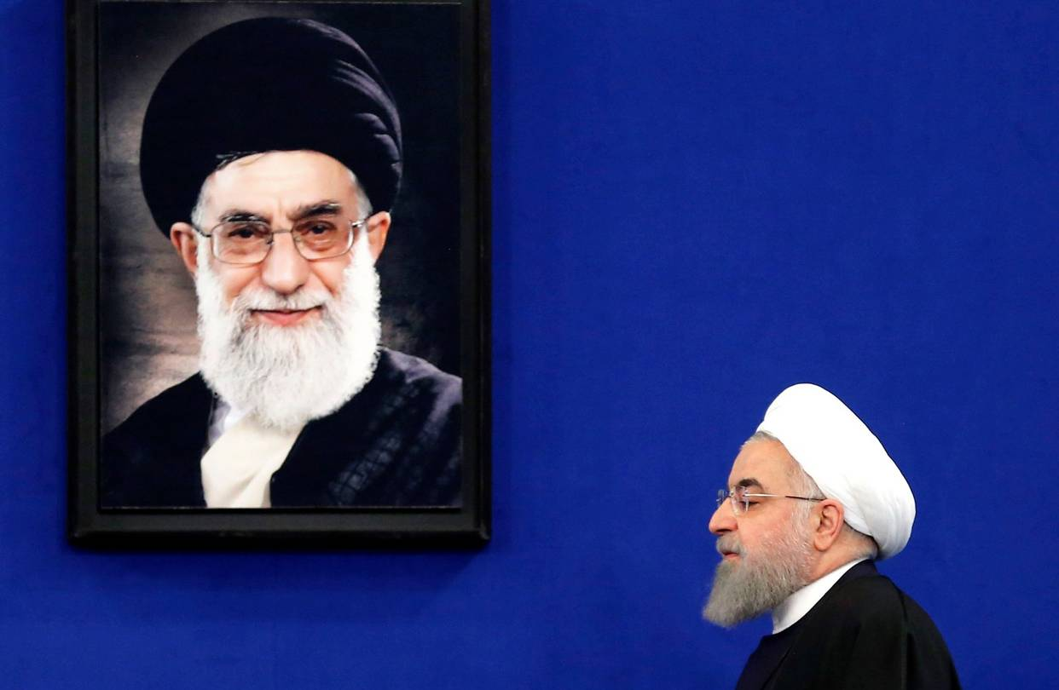
Iranian President Hassan Rouhani at a press conference in Tehran on Feb. 6. PHOTO: ATTA KENARE/AGENCE FRANCE-PRESSE/GETTY IMAGES
Iran’s Islamic revolutionaries criticize each other regularly, but recently the level of invective among the ruling elite has reached new heights. The vicious infighting between President Hassan Rouhani and his detractors now threatens the governing edifice of the Islamic Republic. Given the clerical regime’s aggressive foreign policy and nuclear ambitions, it is in America’s interest to see this power struggle intensify.
During the pro-democracy demonstrations in 2009, most of the Iranian ruling class, including Mr. Rouhani, rallied around Ayatollah Ali Khamenei, the supreme leader. In the wake of the smaller but more widespread provincial protests that started last December, revolutionary elites appear divided. These contesting factions are further delegitimizing the state they are trying to save.
This is a contest for power, not ideals. Mr. Rouhani surely is not seeking to liberalize the political system and make it more accountable to the citizenry. A founding father of the theocratic regime who remains deeply implicated in many of its worst crimes, Mr. Rouhani seeks to make the economy work without structural reforms that would free it from clerical control. He hopes that Western investment can help Iran’s corrupt, mismanaged economy grow.
Mr. Rouhani has now transformed himself into a democrat and populist, albeit a deeply cynical one. Taking a swipe at Iran’s unelected leaders, he recently insisted that “elections are the only means to govern” and “criticism and protest are the people’s right.” The defiant president has called for a referendum on democracy: “When the revolution happened, we were all together aboard the train of the revolution; some of us decided to get off the train; others we forced off whom we should not have. All should be invited back on the ‘success and a victorious revolution’ train.”
Then there’s the mysterious leak of video from a 1989 Assembly of Experts meeting. The group, which chooses the supreme leader of Iran, was weighing whether to approve Mr. Khamenei’s ascension to the post. “Pity an Islamic society,” Mr. Khamenei confesses in the video, “if even the possibility is raised that someone like me can be its leader.” It is hard not to see the hands of the president and his allies behind this humiliation.
The same is true for the recent budget disclosure, which showed higher-than-expected funds going to the detested virtue police and conservative religious foundations allied with Mr. Khamenei. Mr. Rouhani and his allies appear to be trying to chip away at the regime, but their opponents nonetheless command the country’s most powerful institutions: the office of the supreme leader, the judiciary, the Revolutionary Guards and vigilante groups that often terrorize their critics. The conservative press has mocked the idea of a referendum, while belittling Mr. Rouhani for relying on Westerners to rescue the economy.
The supreme leader has warned that “the enemy is waiting for an opportunity. He is waiting for the emergence of a rift through which he can infiltrate the country.” In an even more stern rebuke, Revolutionary Guard commander Qasem Soleimani warned Mr. Rouhani, “I find it unfortunate that some who are self-styled as followers of the path of the Imam don’t write an open letter to the Global Arrogance (America) but write open letters to the standing [supreme] leader.”
Mr. Khamenei and the Revolutionary Guards harbor their own vision of economic empowerment—the “resistance economy.” They want to jump-start the economy while relying less on Western commerce. Their plan calls for more use of the country’s internal markets and trade with culturally nonthreatening countries like Iraq and Central and East Asian states.
For Mr. Khamenei, Western sanctions revealed that dependence on foreign commerce is a country-crippling vulnerability. Mr. Rouhani differs, seeing the nuclear deal as the gravestone of American-European cooperation against Iran. For him, more European investment will divide the West, neutralizing the more hawkish U.S. Mr. Khamenei and his disciples aren’t enchanted, as Mr. Rouhani is, with the China model, in which autocracy, capitalism and a certain cultural permissiveness coexist. They don’t see China’s vibrant economy and growing military power; they see a regime that has forfeited its ideological inheritance.
Neither Mr. Rouhani’s pragmatic revolutionaries nor Mr. Khamenei and his allies can win this power struggle. The president may be able to agitate government and society, but he cannot reinvent himself as an opposition leader. He is merely strengthening a national narrative that has already rejected clerical rule.
The supreme leader and his supporters can thwart Mr. Rouhani’s legislative agenda and his attempt to refashion the economy. But given their contempt for democracy and their ease with corruption, they cannot rebuild the regime’s battered legitimacy. As the clerical oligarchs plot against one another, the system is likely to grind to a halt. The result of this factional fight is paralysis at a time when the theocracy is facing popular disaffection, economic decline and imperial overstretch.
The White House can crack the regime. Pushback—any pushback—against Tehran’s gains in Syria would help, as would a tidal wave of sanctions against the Revolutionary Guards. The president can also use his bully pulpit and economic sanctions aggressively to expose and punish the regime’s tyrannical behavior.
The potential for a democratic transition exists in Iran, where such aspirations have been growing for over 100 years. As regime-shaking street protests have repeatedly revealed, the country is a volcano. We want it to erupt. For the U.S. and the Middle East, sooner is better than later.
Mr. Gerecht is a senior fellow at the Foundation for Defense of Democracies. Mr. Takeyh is a senior fellow at the Council on Foreign Relations.
Appeared in the March 7, 2018, print edition.

