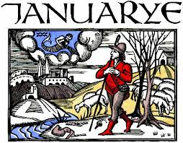 2020
MONDAY | WEDN ESDAY | FRIDAY
6 Nigeria | 8 Nigeria  Blood Oil (Vanity Fair | 10 Nigeria  EBs: Tomlin, Truluck  Smalls, Stec, Wisler  Meese, Ward
13 Nigeria  FRQs | 15 Iran  Test | 17 Iran
20 NO SCHOOL | 22 Iran  Wood: Iran | 24 Iran  Making the Basij
27 Iran  Neda video | 29 Iran  Neda video | 31 Iran  - EBs: Doyle, Golden  Case, Elswick  Bright, Bronovitskiy

