Russia

Inside the bear

When the Soviet Union collapsed 25 years ago, Russia looked set to become a free-market democracy. Arkady Ostrovsky explains why that did not happen, and how much of it is Mr Putin’s fault
Oct 22nd 2016 | From the print edition

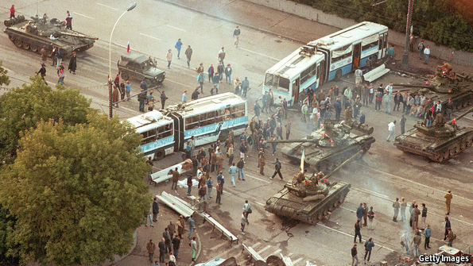
ON AUGUST 20th Guzel Semenova, a 25-year-old Muscovite, was strolling through the grounds of Muzeon, one of the city’s parks, and stopped by a burnt-out, rusty trolleybus. Inside its shattered interior a small video screen was playing black-and-white footage of events that unfolded in the year she was born. A volunteer explained that the trolleybus had been part of an anti-tank barricade during a coup 25 years ago and symbolised the people’s victory. Ms Semenova looked confused. The 22-year-old volunteer, herself unsure what exactly had happened during those three days in August 1991, said it was when “Russia became free.” Ms Semenova listened politely, then walked on.
A patchy knowledge of those events is nothing unusual in Russia. A survey by the Levada Centre, the country’s leading independent pollster, shows that half the overall population and as many as 90% of young Russians know nothing about the drama that began in the small hours of August 19th 1991.
That morning the world woke up to news of a coup. Mikhail Gorbachev, the last Soviet leader, was detained in Crimea, “unable, for health reasons, to perform his duties”. Power had been seized by a group of hard-line Communists, the chief of the KGB and senior army generals, who declared a state of emergency. Tanks were rumbling through the centre of Moscow. The television, overrun by the KGB’s special forces, was playing Tchaikovsky’s “Swan Lake” on a loop. It was a last, desperate attempt to save the disintegrating empire.
But on the day of the coup not a soul came out to support the Soviet regime. Instead, tens of thousands of Muscovites took to the streets to build barricades and defend their new freedoms. Boris Yeltsin, the first democratically elected president of Russia, then a subordinate part of the Soviet Union, called for resistance. The KGB’s special forces were told to attack the Russian parliament, the epicentre of the opposition, but nobody was prepared to give a written order. Two days later three young men died under a tank. A few hours after that the troops were withdrawn and Gorbachev returned to Moscow. Jubilant crowds marched to the KGB’s headquarters and toppled the statue of its founder, Felix Dzerzhinsky.
Those three days marked the end of the Soviet Union, but they did not become a foundation myth for a new Russia. The country was tired of myths. Modern school textbooks barely mention them. Russian officials used to lay flowers at a small monument to the three young men killed by the tanks, but even this modest gesture stopped in 2004. This year liberals were banned from marching to the place of their victory 25 years ago. The small festival at the Muzeon attracted a few hundred people who watched a stylised performance of “Swan Lake” and a documentary from those days. Shot in St Petersburg, the cradle of the Bolshevik revolution, it showed a vast, peaceful crowd in the main square watching the death throes of the Soviet empire. The camera also captured a young Vladimir Putin by the side of his boss, Anatoly Sobchak, then the mayor of St Petersburg, who had defied the coup. A demonstrator was heard to shout: “When we get rid of the communist plague, we will again become free and we won’t have to fight [a war] again.”
The revolution of 1991 overturned the Soviet Union’s political, economic and social order and put 15 countries on the map where there had previously been only one. But like many revolutions in history, it was followed by a restoration.
The tsar the Kremlin most admires is Alexander III, who on taking office in 1881 reversed the liberalisation overseen by his father, who was assassinated, to impose an official ideology of Orthodoxy, nationalism and autocracy. His portrait and his famous saying, “Russia has only two allies: its army and its navy,” greet visitors to a revamped museum of Russian history at VDNKH, a prime example of Stalinist architecture in Moscow. Stalin himself has had a makeover too. Gigantic portraits of him line the roads in Crimea, proclaiming: “It is our victory!”
The two main pillars of the Soviet state, propaganda and the threat of repression, have been restored. The KGB, which was humiliated and broken up in the aftermath of the coup, has been rebuilt as the main vehicle for political and economic power. The secret police is once again jailing protesters and harassing civil activists. In September the Kremlin designated the Levada Centre a “foreign agent”, which could be the end of it. Television has been made into a venomous propaganda machine that encourages people to fight “national traitors” and “fifth-columnists”. Boris Nemtsov, a liberal politician who once represented Russia’s hopes of becoming a “normal” country, was murdered outside the Kremlin last year.
After nearly a decade of economic growth spurred by the market reforms of the 1990s and by rising oil prices, the Russian economy has descended into Soviet-era stagnation. Competition has been stifled and the state’s share in the economy has doubled. The military-industrial complex—the core of the Soviet economy—is once again seen as the engine of growth. Alternative power centres have been eliminated. Post-Soviet federalism has been emasculated, turning Russia into a unitary state.
Reactionary restoration at home has led to aggression abroad. Russia has invaded Georgia and Ukraine, two of the most democratic former Soviet republics. It has intervened in the conflict in Syria, propping up the regime of President Bashar al-Assad. It has attempted to undermine Euro-Atlantic institutions, backed right-wing parties in Europe and tried to meddle in America’s presidential election. And it is once again using the threat of nuclear arms to blackmail the West.
After the defeat of the 1991 coup, Russia was widely expected to become a Westernised, democratic, free-market country. This special report will explain why that did not happen, and ask whether the West has a Putin problem or a much deeper and more enduring Russia problem.
Mr Putin was originally chosen for the top job by Yeltsin, Russia’s first president, not least for being on the “democratic” side in 1991. When he came to power in 2000, he was expected to consolidate the country. Instead, he has reinstated an archaic model of the state.
It was naive to expect that after 74 years of Soviet rule, and several centuries of paternalism before that, Russia would rapidly emerge as a functioning Western-style democracy. But this report will show that Russia’s relapse into an authoritarian corporate state was not inevitable. It was the result of the choices made by the country’s elite at each new fork in the road. And although those choices cannot be unmade, they do not predetermine the future.
Not the Soviet Union
The collapse of the Soviet Union brought a massive change to Russia. The creation of private ownership launched industries that did not exist before, such as private banks, restaurants and mobile-phone networks. People are free to make money, consume and travel on a scale never seen before in Russia’s history. They consume not just more goods and services but more culture and information. The state no longer dominates people’s lives. Although it controls television, the internet remains largely unconstrained everywhere, and radio and print still have some freedom. Even Alexei Navalny, an opposition politician, admits that “despite the curtailing of political and civil freedoms, the past 25 years have been the freest in Russian history.”
People are becoming increasingly alienated from politics, as demonstrated by the low turnout in the parliamentary elections in September, but they are finding other ways of expressing their views. Although few Russians remember quite how the Soviet regime ended, many enjoy the results. Russia has a vibrant urban middle class which, until recently, was richer than its equivalents in eastern Europe. Russia’s cities, with their cafés, cycle lanes and shopping streets, don’t look very different from their European counterparts.
A new generation of Westernised Russians born since the end of the Soviet Union has come of age. The children of the Soviet intelligentsia—a vast educated professional class that supported Gorbachev—dress, eat and behave differently from their parents’ generation. They have a spring in their step.
Many of these young, educated Russians owe their comfortable lives to a decade of economic growth that began in 1998 and ended with the economic crisis in 2008-09. The impact of that crisis exposed the limits of Mr Putin’s model of governance. And although economic growth recovered fairly quickly, trust in Mr Putin’s model of governance declined sharply, from 35% at the end of 2008 to 20% in early 2012, whereas support for Western-style democracy shot up from 15% to 30%.
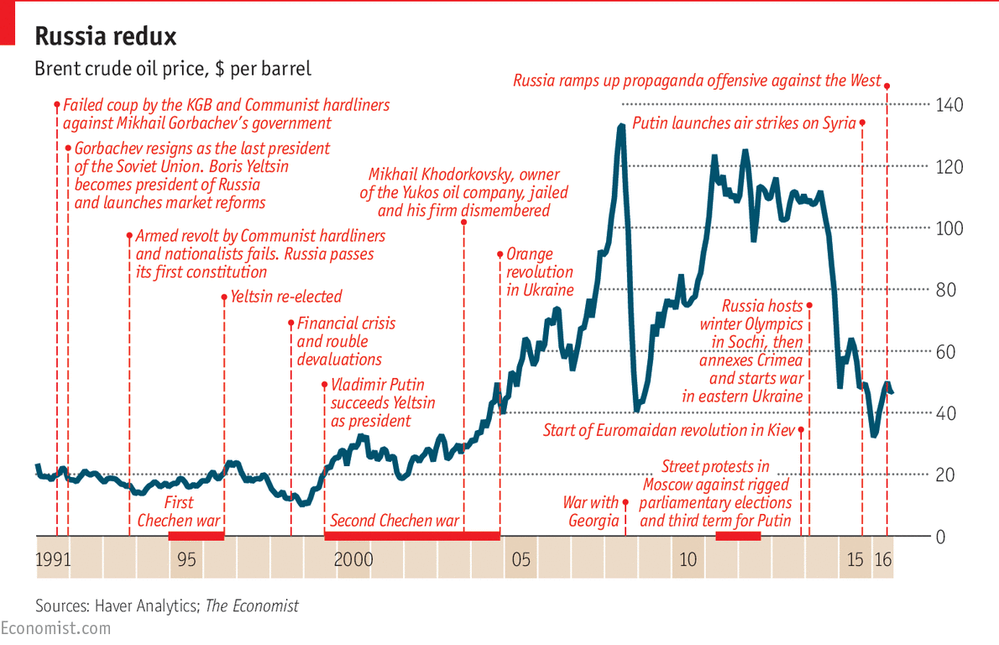
Those who felt that Russia needed both economic and political modernisation pinned their hopes on Dmitry Medvedev, who served as president from 2008 to 2012. The Russian elite wanted him to stay for a second term, but in September 2011 he announced that Mr Putin, who was then prime minister, would resume the presidency, while Mr Medvedev would become prime minister. He indicated that this job swap had been planned right from the start of his presidency. Many people felt they had been duped. When three months later the Kremlin blatantly rigged the parliamentary elections, they took to the streets, demanding the same sort of respect from the state as citizens as they were enjoying as private customers at home and abroad. They wanted Russia to become a European-style nation state, an idea formulated by Alexey Navalny, an anti-corruption blogger who had galvanised the protests through social media. His definition of the governing United Russia as a party of “crooks and thieves”, and the mood of protest, spread across the country.
Mr Putin was rattled and angry, but having witnessed the failure of the 1991 coup he knew that tanks were not the answer. Instead he trumped civic nationalism with the centuries-old idea of imperial or state nationalism, offering the idea of Russia as a besieged fortress. In 2014 he annexed Crimea. The tactic worked. The protests stopped and Mr Putin’s personal approval ratings shot up from 60% to 80%. By attacking Ukraine after its own revolution in 2014, Mr Putin persuaded his country and its neighbours that any revolt against the regime would be followed by bloodshed and chaos.
Smoke and mirrors

Mr Putin’s Russia is a slippery construct in which simulation and bluff play a big part
The Soviet Union had many faults, but postmodernism was not one of them. Mr Putin’s Russia is a more slippery construct in which simulation and bluff play a big part. Nothing is what it seems. Elections are held not to change power but to retain it; licensed “opposition” parties are manufactured by the Kremlin; Mr Medvedev’s modernisation was an illusion; doctorates awarded to scores of Russian officials, governors and even to Mr Putin himself were based on plagiarism or cheating, according to Dissernet, a grassroots organisation.
In 2014 Russia put on a remarkable show with the costliest winter Olympics ever staged, in Sochi on the Black Sea. The host country’s athletes got the largest number of gold medals, not least thanks to a massive doping operation in which the Federal Security Service (FSB), the KGB’s successor and Russia’s main security organisation, swapped urine samples through a hole in the wall between an official laboratory and a secret one next door. (That caused many Russian athletes to be banned from this year’s Rio Olympics.) In the same way that Russia has been doping its athletes, its state media have been doping the population with military triumphs and anti-American propaganda, conveying an artificial sense of strength. But unlike those sport victories, Russian violence in Ukraine and Syria is real enough.
Mr Putin’s restoration project is working because the disintegration of the Soviet Union was not complete. The remains of the Soviet and even pre-Soviet system, its institutions, economic structure and social practices, which lay dormant during the first post-Soviet decade, have been revived and strengthened by the current regime.
But just as the Soviet and pre-Soviet legacies cannot be erased, nor can the quarter-century since the USSR ceased to exist. The fundamental conflict between a modern lifestyle and the political restoration under Mr Putin, exposed by the protests of 2011-12, has been suppressed, not resolved. No restoration has ever ended in a return to the past, and none has been permanent.
Russia, perhaps more than other countries, advances through generational shifts. The current reactionary phase may turn out to be no more than a detour on the path towards a modern, federalist nation state. Or it could lead to further decline, interspersed with outbursts of aggression. Which is it to be?

