Years | President | Election | Key Domestic Events | Foreign Policy Events/Issues | Other Issues/Events
1952  1957-  1961 | Eisenhower,  Dwight  (Republican)  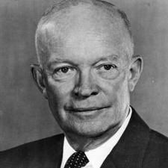
1960  1961-1963) | Kennedy,  John  (Democrat)  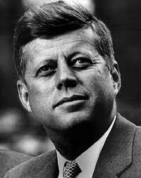
1964  1963-1969 | Johnson,  Lyndon  (Democrat)  