How U.S. sanctions are paralyzing the Iranian economy
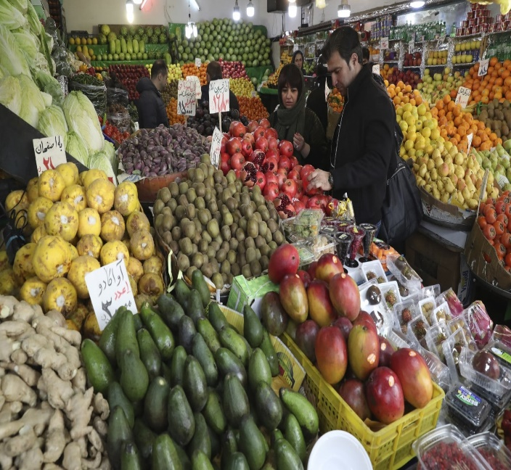Prices of consumer goods in Iran, including food, have risen sharply in the past few years as the country faces sanctions from the United States and its allies. (Vahid Salemi/AP)
By
Rick Noack, Armand Emamdjomeh and Joe Fox
Jan. 10, 2020 at 4:16 p.m. EST
The Trump administration announced more sanctions Friday on Iran, marking the latest move in a series of financial U.S. punishments that have left the Iranian economy reeling and its citizens under extreme pressure.
The latest U.S. sanctions will target Iran’s metal industries, as well as eight senior military and national security officials. The new penalties came after the U.S. killing of a top Iranian commander in Baghdad last week, which triggered retaliatory Iranian strikes Wednesday on bases housing U.S. military personnel in Iraq.
Within three years, cautious hopefulness on improving U.S.-Iranian relations has turned into escalating hostility — with ordinary Iranians saying they once again will bear the brunt of it.
“Every single day, as soon as people open their eyes, they face a dark and vague future,” wrote Iranian musician Mehdi Rajabian, 30, an independent protest artist and frequent critic of the Iranian regime, in a text message.
AD
When the Iran nuclear deal was reached in 2015, then-President Barack Obama welcomed it as being “not built on trust,” but rather “on verification.” The agreement — one of his signature foreign policy achievements — was implemented in early 2016.
Suddenly and largely unconstrained by international sanctions, foreign companies flocked into the country. Whereas Iran’s real gross domestic product growth rate stood at -1.3 percent in 2015, it surged to +13.4 percent in 2016.
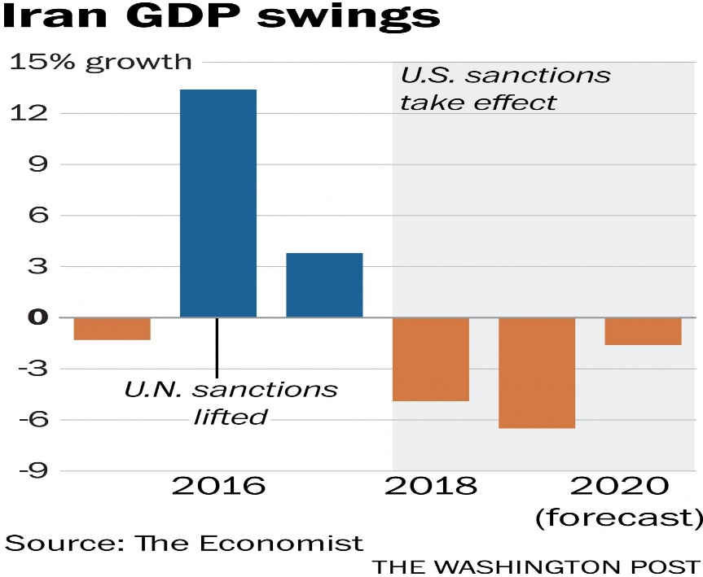

But President Trump’s election in November 2016 and his new policy directives upended that. Iran’s real GDP growth rate tumbled.
Throughout his campaign, Trump had argued the United States should leave the Iran agreement, calling it a “terrible one for the United States and the world. It does nothing but make Iran rich and will lead to catastrophe,” he tweeted in 2015.
AD
On May 8, 2018, Trump followed through, announcing that the United States would abandon the deal. “It didn’t bring calm, it didn’t bring peace, and it never will,” he said. Trump’s supporters argued that Iran had deceived the international community and that it continued to destabilize the Middle East undeterred, via proxies in Yemen, Lebanon, Syria and other parts of the region.
Other Western parties to the deal — Germany, France and Britain — countered that stopping Iran’s regional interference was never its aim and that their own intelligence suggested Iran was in compliance with the agreement. All signatories apart from the U.S. stuck to the agreement. Europe announced it would establish a mechanism to shield companies willing to continue trading with Iran from reinstated U.S. sanctions.
Once key U.S. sanctions were reinstated by November 2018, however, the Europeans’ announcement had little impact. The Iranian rial continued to rapidly lose value against the dollar.
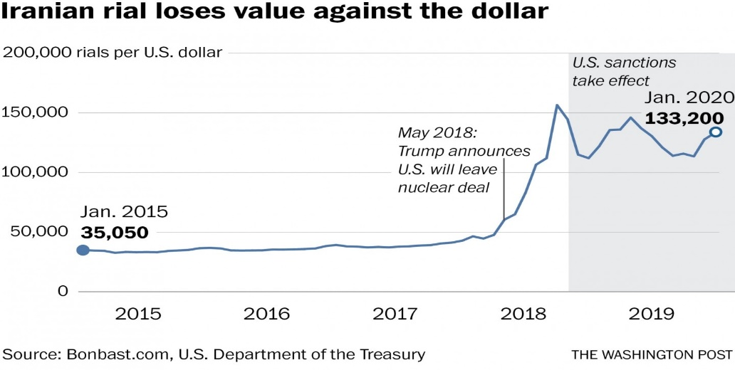

The Trump administration’s threat to also impose sanctions on countries that purchased Iranian oil hit Iran especially hard. Iran’s oil exports plummeted after the sanctions took effect.
Initially, the United States agreed to grant some of Iran’s customers a six-month waiver, meaning they could continue to import Iranian oil without fear of U.S. sanctions. In the following months, Iranian oil exports began to increase as a result of the exemptions.
Once the waivers expired in May 2019, Iranian exports fell to new lows.
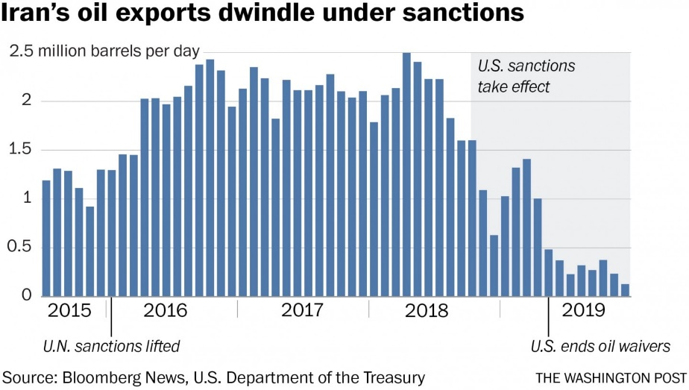

There have been signs of recent frustration between Tehran and the European Union, too. Iranian officials have blamed their European counterparts for supposedly being too slow in implementing measures to shield companies from U.S. sanctions.
In response to the U.S. killing of Maj. Gen. Qasem Soleimani, commander of Iran’s elite Quds Force, Tehran doubled down by announcing on Sunday that it was suspending its commitments under the nuclear deal.
For now, the European Union has resisted U.S. pressure to declare the nuclear deal dead, saying instead that it will “spare no effort” to keep it alive.
A key question, however, is whether additional sanctions would even have a significant impact. Analysts say existing U.S. sanctions have left little leeway for Iran, which saw the cost of basic goods skyrocket over the past year.

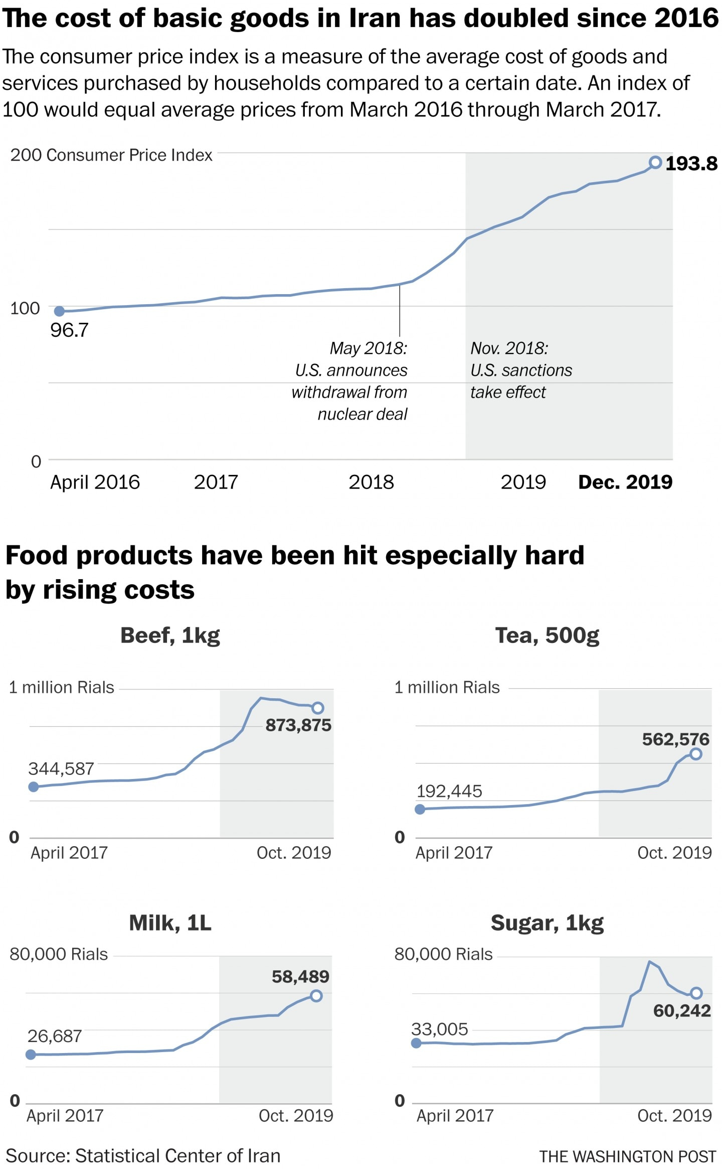
Over the course of one year, the price of beef and veal has risen nearly 50 percent, and the cost of milk has almost doubled.
Iranian government leaders “keep telling us to be strong and endure the pressures, but we can already hear the sound of our bones breaking,” Shiva Keshavarz, a 22-year-old accountant, told the Associated Press last summer.
Since then, living conditions have only gotten harsher for many Iranians, who “struggle to survive,” wrote Rajabian, the musician.

