Halloween's origins date back to the ancient Celtic festival of Samhain (pronounced sow-in).
The Celts, who lived 2,000 years ago in the area that is now Ireland, the United Kingdom, and northern France, celebrated their new year on November 1. This day marked the end of summer and the harvest and the beginning of the dark, cold winter, a time of year that was often associated with human death. Celts believed that on the night before the new year, the boundary between the worlds of the living and the dead became blurred. On the night of October 31, they celebrated Samhain, when it was believed that the ghosts of the dead returned to earth. In addition to causing trouble and damaging crops, Celts thought that the presence of the otherworldly spirits made it easier for the Druids, or Celtic priests, to make predictions about the future. For a people entirely dependent on the volatile natural world, these prophecies were an important source of comfort and direction during the long, dark winter.
To commemorate the event, Druids built huge sacred bonfires, where the people gathered to burn crops and animals as sacrifices to the Celtic deities.
During the celebration, the Celts wore costumes, typically consisting of animal heads and skins, and attempted to tell each other's fortunes. When the celebration was over, they re-lit their hearth fires, which they had extinguished earlier that evening, from the sacred bonfire to help protect them during the coming winter.
By A.D. 43, Romans had conquered the majority of Celtic territory. In the course of the four hundred years that they ruled the Celtic lands, two festivals of Roman origin were combined with the traditional Celtic celebration of Samhain.
The first was Feralia, a day in late October when the Romans traditionally commemorated the passing of the dead. The second was a day to honor Pomona, the Roman goddess of fruit and trees. The symbol of Pomona is the apple and the incorporation of this celebration into Samhain probably explains the tradition of "bobbing" for apples that is practiced today on Halloween.
By the 800s, the influence of Christianity had spread into Celtic lands. In the seventh century, Pope Boniface IV designated November 1 All Saints' Day, a time to honor saints and martyrs. It is widely believed today that the pope was attempting to replace the Celtic festival of the dead with a related, but church-sanctioned holiday. The celebration was also called All-hallows or All-hallowmas (from Middle English Alholowmesse meaning All Saints' Day) and the night before it, the night of Samhain, began to be called All-hallows Eve and, eventually, Halloween. Even later, in A.D. 1000, the church would make November 2 All Souls' Day, a day to honor the dead. It was celebrated similarly to Samhain, with big bonfires, parades, and dressing up in costumes as saints, angels, and devils. Together, the three celebrations, the eve of All Saints', All Saints', and All Souls', were called Hallowmas.
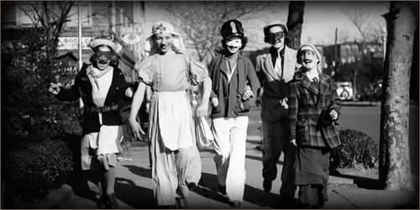
As European immigrants came to America, they brought their varied Halloween customs with them. Because of the rigid Protestant belief systems that characterized early New England, celebration of Halloween in colonial times was extremely limited there.
It was much more common in Maryland and the southern colonies. As the beliefs and customs of different European ethnic groups, as well as the American Indians, meshed, a distinctly American version of Halloween began to emerge. The first celebrations included "play parties," public events held to celebrate the harvest, where neighbors would share stories of the dead, tell each other's fortunes, dance, and sing. Colonial Halloween festivities also featured the telling of ghost stories and mischief-making of all kinds. By the middle of the nineteenth century, annual autumn festivities were common, but Halloween was not yet celebrated everywhere in the country.
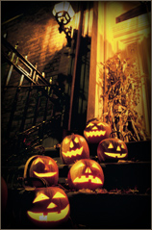
In the second half of the nineteenth century, America was flooded with new immigrants. These new immigrants, especially the millions of Irish fleeing Ireland's potato famine of 1846, helped to popularize the celebration of Halloween nationally. Taking from Irish and English traditions, Americans began to dress up in costumes and go house to house asking for food or money, a practice that eventually became today's "trick-or-treat" tradition. Young women believed that, on Halloween, they could divine the name or appearance of their future husband by doing tricks with yarn, apple parings, or mirrors.
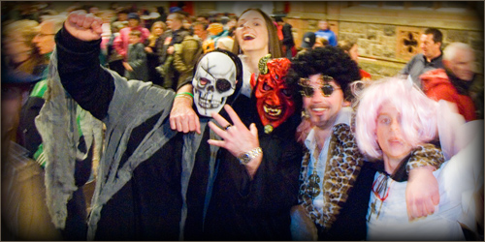
In the late 1800s, there was a move in America to mold Halloween into a holiday more about community and neighborly get-togethers, than about ghosts, pranks, and witchcraft.

The American tradition of "trick-or-treating" probably dates back to the early All Souls' Day parades in England. During the festivities, poor citizens would beg for food and families would give them pastries called "soul cakes" in return for their promise to pray for the family's dead relatives.
The distribution of soul cakes was encouraged by the church as a way to replace the ancient practice of leaving food and wine for roaming spirits. The practice, which was referred to as "going a-souling" was eventually taken up by children who would visit the houses in their neighborhood and be given ale, food, and money.
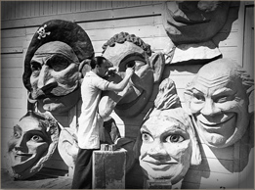
.
Photo Credit: Corbis
The tradition of dressing in costume for Halloween has both European and Celtic roots. Hundreds of years ago, winter was an uncertain and frightening time. Food supplies often ran low and, for the many people afraid of the dark, the short days of winter were full of constant worry. On Halloween, when it was believed that ghosts came back to the earthly world, people thought that they would encounter ghosts if they left their homes. To avoid being recognized by these ghosts, people would wear masks when they left their homes after dark so that the ghosts would mistake them for fellow spirits. On Halloween, to keep ghosts away from their houses, people would place bowls of food outside their homes to appease the ghosts and prevent them from attempting to enter.

