From Selma to Black Power
Only a few miles away from where the legendary march began, a new phase of civil-rights activism found its voice.
BENJAMIN HEDINMAR 6 2015, 7:30 AM ET
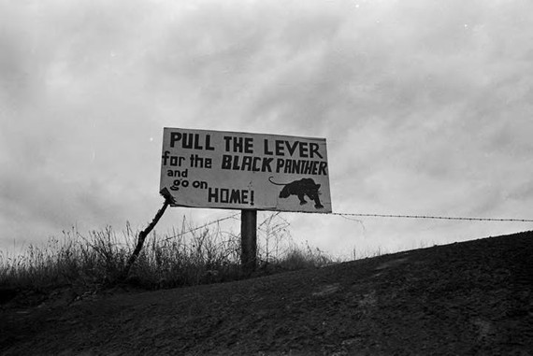A roadside sign for the Lowndes
Anyone who was not a diehard white supremacist could see the march from Selma to Montgomery in 1965 for what it was: a myth in motion, advancing east through the Alabama countryside at two miles an hour. It recalled other famous wanderings, like the trek of the Israelites and Gandhi’s 1930 pilgrimage to the sea, and ended in a place of rich historical association. Montgomery was named the first capital of the Confederacy in 1861, and when Martin Luther King, Jr. addressed the crowd at the march’s end he stood on the spot where just two years earlier George Wallace had declared “segregation now, segregation tomorrow, segregation forever.” With passage of the Voting Rights Act at hand, there could be no better place to hold the victory party.
The march itself was a spectacle or symbol, hugely necessary and memorable, but what the power of the ballot actually meant—how it would affect the lives of African Americans, especially in the South—had yet to be decided. One answer came in the days after with the first stirrings of a new political party in the county adjacent to Selma. That party, which took the black panther as its symbol, moved the debate from the theoretical equality of the Voting Rights Act to the practical reality of Black Power.
The march to Montgomery took place on Highway 80, a road that traverses Alabama’s Black Belt and narrows to two lanes east of Selma, when it enters Lowndes County. The court order permitting the demonstration stated only three hundred marchers could pass along this section of the road, as one lane had to be left open for traffic. Most of the spots were given to locals, with a few dozen reserved for King’s entourage and other visitors and dignitaries. Not among those three hundred selected was Stokely Carmichael, a field secretary for the Student Nonviolent Coordinating Committee, or SNCC, one of the leading civil rights groups of the day. But he went to Lowndes anyway, with Bob Mants, another SNCC member who had stood in the second line of protestors—immediately behind John Lewis—during the infamous Bloody Sunday attack on Selma’s Edmund Pettus Bridge.
“We trailed that march,” Carmichael later recalled. “Every time local folks came out, we’d sit and talk with them, get their names, find out where they lived, their address, what church, who their ministers were, like that. So all the information,everything, you’d need to organize, we got.”
Lowndes County—where, incidentally, Selma director Ava DuVernay spent her summers while growing up—was rigidly segregated and feudal. Twelve thousand of its 15,000 residents in 1965 were African American. Many worked as tenant farmers on plantations or commuted to domestic jobs in Montgomery. County politics was a strictly white affair since blacks were barred from registering to vote; there was no record of a single African American voting in Lowndes County in the twentieth century.
Carmichael and Mants returned to Lowndes on March 27, 1965—two days after the march to Montgomery ended. They were joined by three others from SNCC. While the organization had canvassed in the area before, these early efforts were looser or less systematic, “a little more scatter gun,” according to Judy Richardson, who was among those visiting the county that day. “What the march allowed us to do was get into better contact with folks who were already activated, who had already thought about organizing around voter registration in Lowndes County.”
In the coming weeks Richardson and the others knocked on doors and met with people, often early in the morning, to review electoral procedures and encourage turnout at mass meetings. They lived in Selma to start, until a couple, Emma and Mathew Jackson, Sr., donated a house for their use. Its four rooms made for a spartan headquarters. The structure sat on cinderblocks, was equipped with one butane heater but no refrigerator or plumbing, and its roof was so shoddy organizers were obliged to carry pots into bed each time it rained.
But comfort was the least of their concerns, for the specter of mob violence trailed their every move. In August of 1965, Jonathan Daniels, a seminarian from New England who attended the march to Montgomery and stayed in Alabama to help SNCC, was gunned down in Hayneville in Lowndes County. Anyone providing help to SNCC faced retaliation. Shots were fired into the Jacksons’ home, and their sixteen year-old son lost his job as a bus driver for sharing the activists’ leaflets with his passengers. Sharecroppers who had been seen at mass meetings or tried to register were sent eviction notices.
SNCC held on, despite the terror and intimidation. “The question became how do we not only get people registered to vote, but how would we begin to deal with the issues that confronted them,” says Courtland Cox, a SNCC organizer who helped coordinate the Lowndes County program in 1965 and 1966. “We have to get people to run for office—people who had not only not run for office but never voted to get engaged in a way that would allow them to think they could run the political mechanisms of the county.”
Carmichael was more blunt. “We intend to take over Lowndes County,” he told one reporter. The attitude and intention signaled an important new direction for SNCC and by extension the whole civil rights movement. The previous year, SNCC had helped recruit an alternate slate of delegates to attend the 1964 Democratic National Convention in Atlantic City. Mississippi’s own delegates, they claimed in a lawsuit, had been illegally appointed, since nearly half the state—its African American population—was effectively disenfranchised. But the appeal was lost; the alternate delegates were not allowed to participate in the convention, and many in the movement concluded that black protest was incompatible with mainstream politics.
“It’s a different tack for SNCC,” Richardson says of the work they did in Lowndes County. “We realized we could no longer operate within the Democratic Party structure and had to think about independent organizing. After Atlantic City it’s very clear that traditional politics is not about morality. It’s about power.”
Jack Minnis, the head of SNCC’s research department, began studying the twelve volumes that comprised the Alabama Code of Laws. He found a statute that permitted independent political parties at the county level; ironically, it was one devised by Confederates during Reconstruction as a way of winning back political control. The party, it said, must hold a convention on the date of the spring primary and nominate candidates for the general election in the fall. If one of them received 20 percent of the vote come November, the state would recognize the party. With the Voting Rights Act taking effect in August of 1965—which meant federal examiners would oversee registration in Lowndes County—20 percent seemed like a manageable figure.
One last stipulation was that each party had to have a logo, in part to aid the unlettered, since back then any Alabaman who could not read would cast a ballot simply by looking at the symbol appearing next to a candidate’s name. Once the party—called the Lowndes County Freedom Organization—was chartered, Cox phoned the SNCC office in Atlanta and said they needed a logo to adorn the membership cards.
“The first thing I did was a bird,” recalls Ruth Howard Chapman, then a member of SNCC’s research team. Minnis, however, disliked the initial drawing, which showed a dove, and mentioned the panther mascot of nearby Clark College (now Clark Atlanta University). “I can remember going over to Clark,” says Chapman, “and going in this office. There was a faculty person there and he pulled out a brochure and we traced that cat. Jack said, ‘Well, that’s fine!’ So we put it on and sent the cards down to Lowndes County.”
The choice seemed especially apt given that the logo for the all-white Alabama Democratic Party was a rooster, and “panthers eat roosters,” as those in SNCC grew fond of saying. “Pull the lever for the Black Panther and go home” became the party’s motto, blazoned on flyers and billboards. A Lowndes County pamphlet found its way to Oakland in 1966, where Huey Newton and Bobby Seale decided to name their own party after the logo. Seale would explain, “I asked Huey, ‘Why would they have a charging black panther?’ Later he came up with the point that if you push a panther into a corner, if he can’t go left and he can’t go right, he will tend to come out of that corner to wipe out its aggressor.”
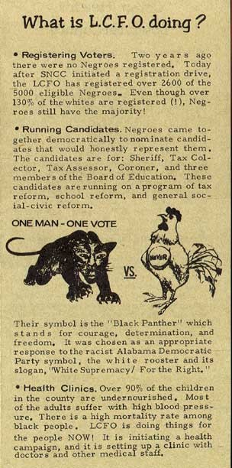An early LFCO pamphlet. (H.K. Yuen Archive)
Newton and Seale were both captivated by Carmichael, who in 1966 unleashed the call for Black Power and became that doctrine’s most prominent exponent. The phrase took on fractured and contorted meanings. Whites beheld it with horror and fascination, but the mysticism surrounding the term obscures the logical and democratic force of its call. Why shouldn’t a community that’s 80 percent African American have a black mayor or probate judge? That was the very question, of course, aired repeatedly last summer during the Ferguson riots. And it’s why Cox regrets how the story of the Lowndes County Freedom Organization has retreated from view, becoming the property of just a few SNCC survivors and academic historians.
“There were a lot of lessons learned and approaches taken that could be very helpful to the movement today,” he says. “I do wish there was a way to celebrate what we did in Lowndes. Not because it should be celebrated for itself, but it’s much more of a model that we need to follow. ‘Every time there’s a problem we need to march; every time there’s a problem we need to make demands.’ We need to get out of that. When the real political issues come up, go out and vote in the numbers, build coalitions. You don’t have that kind of organizational discipline.”
The effects of the Lowndes County coalition would be felt in the next decade and beyond. African Americans were elected to the posts of sheriff and county commissioner in the 1970s, and John Jackson, the teenager who lost his job for distributing leaflets, served as mayor of White Hall, a town in northern Lowndes County, for twenty years. Ultimately, SNCC’s project there should be considered a little known but heroic slant on one of America’s most basic and cherished principles: self-rule. And while the two versions of the Panthers were split on many subjects—a proposed alliance between SNCC and Oakland’s Black Panther Party was eventually called off—this was one aim to which both aspired. After all, when Huey Newton published his platform in 1967, the first item read, “We want power to determine the destiny of our Black Community.”
“If you are going to deal with the issues that affect you,” Cox says today, fifty years on, “you got to figure out how to stop making demands, but making decisions.” For him that remains the legacy of the march from Selma to Montgomery: not the pageantry or symbolic glory of the scene, but the responsibilities it afforded. “You can’t keep asking people who you say oppress you to deal with the nature of your oppression,” he says. “At the end of the day you have to deal with it.”

