China struggles to contain the environmental damage of its rapid growth

Carrie GracieChina editor@BBCCarrieon Twitter
At a conference in Ethiopia this week, the world is discussing the funding for a new set of international goals on sustainable development. Any global attempt to push for sustainability will need the world's biggest country on board. China represents a fifth of the world's population, and after more than three decades of high speed growth it is grappling with the challenge of cleaning up environmental damage and creating a more sustainable future. China Editor Carrie Gracie visited Hunan Province in central China to assess the progress of the cleanup there.
Water should be a life giver. But in the fields of Zhubugang it is a silent killer.
Yang Juqing, 68, is irrigating her fields of green pepper and aubergine. But her water is polluted with industrial waste. She leads me along a fetid ditch which is full of black bubbling water leading back to a high brick factory wall with smokestack chimneys behind.
This land was once known as China's basket of rice and fish. But Zhubugang is also rich in minerals. So as China became the factory to the world, this area became a centre for the chemical industry.
The crops began to suffer: untreated effluent in the water, heavy metals in the soil, sulphur dioxide in the air.
Tendrils of vine wind up a bamboo frame and Mrs Yang reaches across to pluck a winter melon, cracking it open and showing me the rotten inside. She's been farming here all her adult life but she says that in recent years, the crops have been useless.
"Here in this village, many people have cancer. Three people died in the space of as many months. They were all so young. It's so toxic here," Mrs Yang says.
Image captionChina's next generation will depend on leaders making good on their promises for cleaner growth
China is often congratulated for pulling hundreds of millions of people from poverty. But wealth has come at a terrible price. Unregulated smokestack industries have ravaged the environment and damaged the health of generations.
Next door to Mrs Yang, the neighbours are sliding the lid off the well in their courtyard to pump water from twenty metres underground.
They tell me they buy bottled water for the baby, but they can't afford it for the rest of the family.
The wife holds the end of the rope as the husband tentatively lowers the pump down the well shaft. She jerks her chin in the direction of the forest of chimneys on the other side of the fish pond.
"If it wasn't for the factories that would be clean water down there but because of them it's heavily polluted."
Image copyrightAFPImage captionPremier Li Keqiang has said pollution is a "blight on people's quality of life"
It's not just Zhubugang. A fifth of China's arable land is poisoned with heavy metals, most of its groundwater is polluted and some experts say air quality is now a bigger killer than smoking.
Numbers like this are forcing Beijing's hand. Across the country, some of the largest anti-government protests now focus on pollution problems. And the wealthy middle classes in the big cities are increasingly impatient for action to guarantee clean air, water and food.
In March this year Premier Li Keqiang told the annual session of China's parliament, the National People's Congress: "Environmental pollution is a blight on people's quality of life and a trouble that weighs on their hearts…We must fight it with all our might."
From province to city to township level, the message has made its way down to Zhubugang that creating jobs and turning a profit can no longer come at the expense of public health.
All the chemical complexes which have sprung up haphazardly and without regulation have now been ordered to move.
Local environmentalist Song Wei says she is encouraged: "No more economic growth stained by blood. Under the new environment law, every factory has to be approved before it's built. We're putting an end to unregulated chaos."
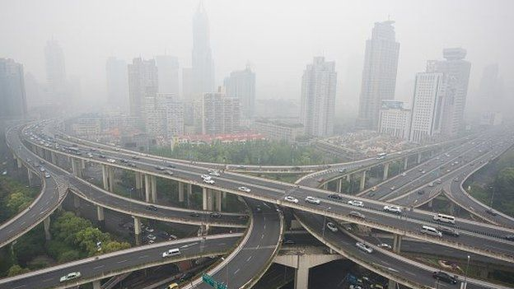Image copyrightAFPImage captionSmog has choked major cities, including Beijing and Shanghai, regularly in recent years
We visit one of the factories forced to move to a dedicated industrial zone, a supplier of enamel paints and glazes for cookware.
Company boss Liang Menlin tells me that in the Zhubugang days, the minerals were mixed by hand, no one bothered with masks and there was toxic dust everywhere. Now the minerals are machine ground in sealed chambers and dust is extracted by vacuum pumps.
"Internationally, standards are rising and technology is more advanced. What's more, environmental inspections are much more frequent than in the old days. Traditional methods of manufacturing have to give way to the big trend for environmental protection. No company can afford to fall behind."
As for the basket of fish and rice that all these people remember from the Zhubugang of their childhood, there is no going back. The soil is too contaminated to be farmed again. Instead factory sites will be reassigned as urban real estate and the remaining farmers will be moved out to apartment blocks.

Right incentives
Pan Jiahua of the Research Centre for Sustainable Development at China's Academy of Social Sciences reminds me of the enormous pressure that urbanisation itself places on China's resources and ecology.
"The real concern is consumer behaviour. People want a modern, comfortable way of life…a big car, a large apartment, air-conditioning in the summer, heating in the winter. All of this is new in China. It's not wrong but it's so vast and so sudden. We are just not prepared for the consumption of energy and natural resources," Prof Pan says.
But Prof Pan is confident that with the right incentives for government officials and a determination to enforce regulations, China will move from its headlong rush for growth to a future of sustainable development.
"Now we have the investment, the demand, the technologies, the determination. If we decide to get things done I don't think that will be a huge challenge."
Image captionChina's rapid industrial growth has left children like Yangyang as victims
Everyone has a stake in Prof Pan being right, and for some its urgent. The Zhubugang sprawl is being demolished, but close by lies another maze of crumbling factories and according to the families who live among them, they show no sign of leaving.
Next door to a foundry, we visit three-year-old Yangyang who has three times the safe level of lead in his blood. The air smells foul and stings our eyes.
As Yangyang spins round the yard on his scooter, his grandmother tells me she's never had a lungful of clean air in her life. His father says they are all the voiceless victims of the country's rush for wealth.
"The central government has good intentions. It does want to clean up the pollution. But we don't know where the money goes on the way down the chain. By the time it gets down here there isn't any money left."
Yangyang's father washes an apple in a tin basin, pointing out that he has no idea how safe either the water or the apple is to Yangyang's health.
So how confident is he that the air will improve in his son's lifetime?
"Things should get a bit better …maybe in ten years or twenty years, things should improve somewhat."
China has a long, long way to go to make good on its promise to children like Yangyang: a sustainable future in which every life counts.

