China finally starts to write a proper civil code
But the party will remain the final judge
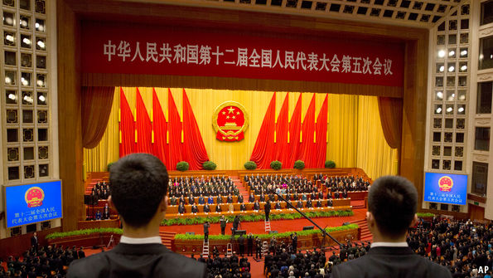
Mar 16th 2017| BEIJING

THE National People’s Congress (NPC), China’s rubber-stamp parliament, wrapped up its annual session on March 15th. Usually its business is unremarkable. This year, however, a piece of legislation that was passed on the final day may prove unusually important. It is known by the unlovely name of the General Principles of Civil Law. It sets the stage for China to pass its first civil code, an overarching law governing legal disputes other than those involving crimes.
China has a civil-law system, which means that statutes are essential reference for judges. (In common-law countries such as Britain and America, verdicts are also decided according to precedent: ie, previous rulings by courts.) But under Communist rule, China has muddled through without a unified civil code. It has bits of one. It passed an inheritance law in 1985, a contract law in 1999 and a property law in 2007. But there are big gaps and inconsistencies. The Supreme People’s Court, the highest judicial authority, issues directives in an attempt to sort these out.
The country has been trying to write a civil code since 1954. But China’s then ruler, Mao Zedong, was lukewarm about it—he did not want any law that might restrict his power. China’s current leaders are far keener to have one. They hope it will provide a stable legal framework for a rapidly evolving society racked by increasingly complex disputes. In 2014 they decided to try again, aiming to write one by 2020. This week’s approval of the code’s general principles is the first fruit. It covers everything from individual rights and the statute of limitations to whether fetuses can own property (they can).
The preamble updates and expands one that was adopted in 1986, when the legal system still looked much like the Soviet Union’s. In defining a company, for example, the old principles talked only about state-owned or collective enterprises, as well as joint ventures with foreign firms. The new preamble has a more useful definition: “a legal entity established for the purposes of making profits”. The old version did not mention privacy. The new one says citizens have a right to it. The old principles said that “where there is no provision of law, activities must be in accordance with state policy.” Strikingly, that clause has been deleted.
Advertisement
Some of the new principles have been set out before. Privacy rights, for example, are in the tort bill of 2009. But their inclusion in the revised preamble gives them more authority.
Not all the changes are for the better. In a section on protecting personal reputations, the new preamble makes it an offence to defame “heroes and martyrs”. That is likely to have a chilling effect on historical inquiry. Qiao Xiaoyang, the head of the NPC’s law committee, says the civil code “upholds private rights”. But the ones mentioned in the law, such as the rights to life, health, and reputation, do not cover the full range.
A civil code—embracing laws of property, contract, inheritance, family and marriage—will not guarantee fairness. The Communist Party will continue to ignore the law when it wants to. But for all the legal system’s flaws, many people still use it. The code may make it less opaque and outdated, and judges’ lives easier.

