The 'Niger Delta Avengers' have a message for Big Oil, and it involves explosives

Militants operating in Nigeria's southern delta region appear to be sending Big Oil a message with a string of renewed attacks on the nation's energy infrastructure: Let sleeping dogs lie, or pay the price.
The Nigerian National Petroleum Corp. said Wednesday that militants bombed the country's second-largest pipeline system just two days after it resumed operations following an attack in July.
No one has yet claimed responsibility for the bombing, which followed other recent strikes that broke weeks of relative calm as the government and militants sought to hold talks. The attacks show the region's most prolific insurgent group, known as the Niger Delta Avengers , and other militants they've inspired, are willing to make good on threats to launch a second wave of attacks on foreign oil companies that defy the group's order to leave sabotaged infrastructure unrepaired until the government meets its demands.

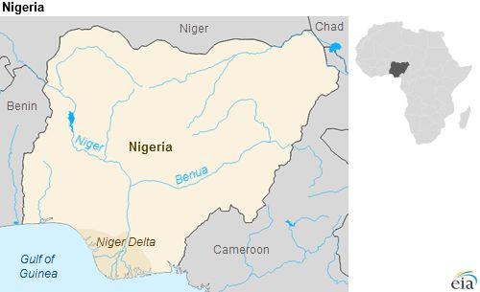
View photos

The Avengers want the impoverished delta region of Nigeria to receive a greater share of the nation's oil revenue, and they've pushed their demands through a campaign of attacks that began earlier this year.
Just last week, the Avengers claimed responsibility for an attack on a pipeline that feeds the Escravos offshore terminal operated by Chevron's Nigerian subsidiary. Last spring, Chevron (NYSE: CVX) briefly closed the facility for the first time in its nearly 50-year history due to fighting in the area.
"This action is to further warn all [international oil companies] that when we warn that there should be no repairs pending negotiation/dialogue with the people of the Niger Delta, it means there should be no repairs," the Avengers said in a statement last week.
Wednesday's target, a flow station along the Trans Forcados pipeline, which feeds Royal Dutch Shell (London Stock Exchange: RDSA-GB)'s Forcados export terminal. That terminal itself just recently resumed exports following a sophisticated underwater attack carried out by the Avengers, which limited activity for eight months.
Other militants have not displayed the same capabilities as the Avengers, but Wednesday's attack is nevertheless troubling because it targeted onshore infrastructure, which should be easier to defend than an offshore terminal, said Ayso van Eysinga, an associate in the Eurasia Group's Africa division.
"It shows some kind of capacity to get around the armed forces, which shows the limitations of how much you can defend the creeks," he told CNBC, referring to the intricate maze of waterways that make up much of the delta.
John Campbell, former U.S. ambassador to Nigeria, told CNBC last week that he strongly suspects that individual members of the various militant groups are not bound by a core mission or even dedicated to any single group, but are instead jumping from one organization to another based on who will pay them the most for carrying out raids.
Manji Cheto, senior vice president at Teneo Intelligence, concurred with that assessment, and raised a troubling prospect: the growing number of militant groups may be the result of an emerging leadership struggle within the Avengers.
"The big thing I'm watching is to what extent the proliferation of this group actually results in them turning against each other," she told CNBC.

