Agendas AP HUG August 27 & 29, 2019
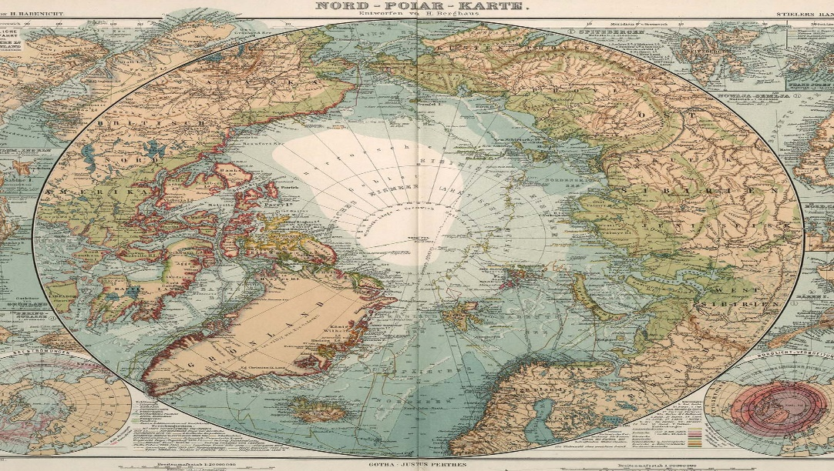
August 27
- AMSCO Quiz
- Lecture

August 28
- Rosling “Quiz”
- Country Snapshot
- Select two countries, one developed and one developing, to study all year.
- Create a two-Page document that has the following components:
- A map of your country and its bordering nations
- A list of what you consider the 4 most important geographic feature of each country along with an explanation as to why you consider those 4 features important
- A chart that includes life expectancy, literacy rates, fertility rates, per capita GNP or GDP, and the 4 biggest exports for each country.

