HUMAN GEOGRAPHY AMSCO CHAPTER ONE

- Location- absolute and relative (p. 5)

- What place is designated as 0 degrees longitude? (p. 5)

- What is the name for the line drawn at 0 degrees longitude? (p. 5)

- What is the name for the line drawn at 0 degrees latitude? (p. 5)

- How is a degree of longitude or latitude further subdivided? (internet)

  - Find the absolute location of the Scholars Academy. (internet)

- How many degrees of longitude do you need to travel across to pass through one “hour” of time (or one time zone)? (internet)

- How many time zones are there? (internet)

- What is the longitude of the International Date Line ?(p.5)

  - Draw the Prime Meridian and International Date Line on the map on the next page.
  - Label the country that moved the International Date Line in 1997.
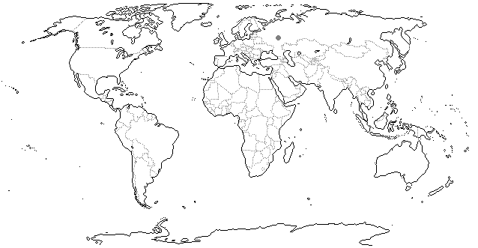

- Define special interaction, friction of distance, and distance decay. (pp.7-8)

- List and define the four types of distribution patterns. (p. 9)

- Define: (p.9)

- cultural ecology
- Environmental determinism
- Environmental possibilism

- Spatial data (p. 10)

- Complete “Thinking Like a Geographer” on p. 16.

