Agendas APCOGO September 9-13, 2019
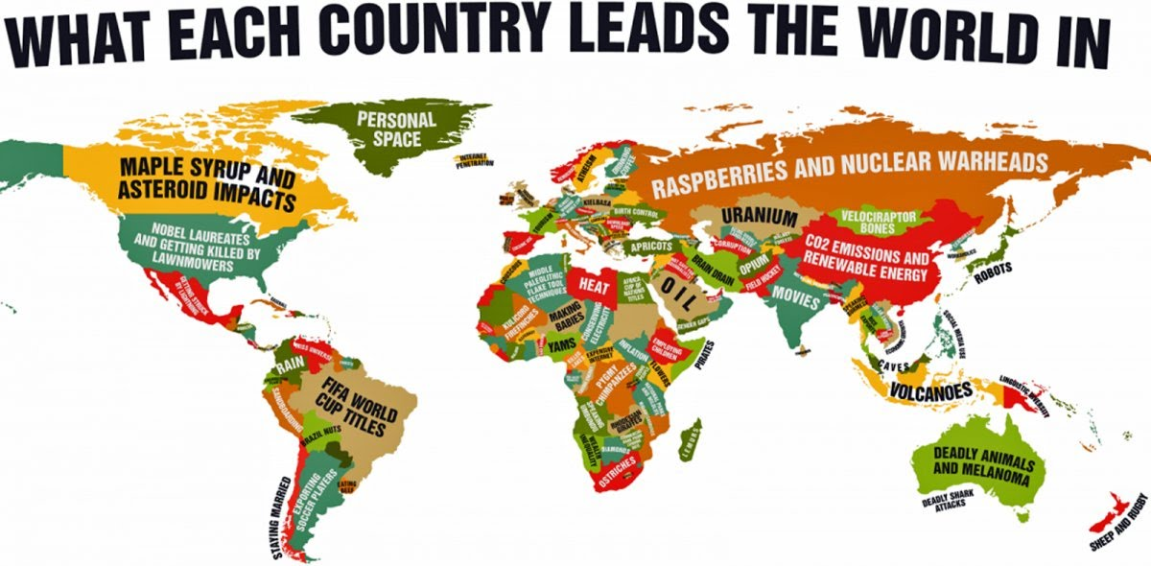

September 9
Lecture

September 11
Vocab Test

September 6
Reading Day- Students will begin Guided reading for the UK chapter.

