Agendas APUSH September 3-6, 2019
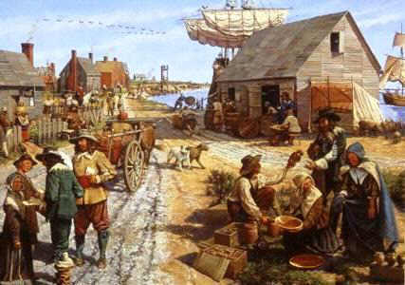

September 3
- Read two excerpts concerning Early Democratic Institutions.
- Answer the three questions under “Questions for Analysis.”
- Video: America: The Story of Us/Rebels
September 4
- Study the Thesis Machine PowerPoint
- Complete the Thesis Machine worksheet using an assigned long essay
September 5
- Quiz: Zinn People of a Mean and Vile Condition
- Fishbowl
- Lecture
September 6
- Each student will read one of five essays concerning the ways history classes portray slavery.
- The students will then walk around the room, sharing their findings with two other classmates who read other essay. They will discuss the thesis, arguments, and evidence found in the essay they read.
- The class will debrief on the five essays as a whole.

