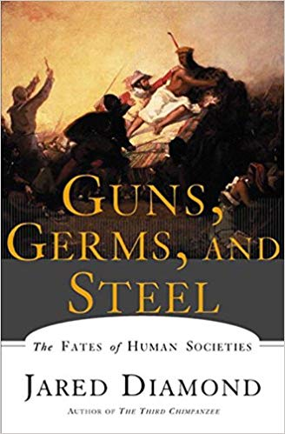
Agendas
APHUG
Sept. 3 & 5, 2019

September 3
- AMSCO 2 Quiz
- Discuss Chapter
- Rosling Quiz

September 5
- Map Game
- Guns. Germs, and Steel, Episode 1

