Agendas APCOGO September 4 & 6, 2019

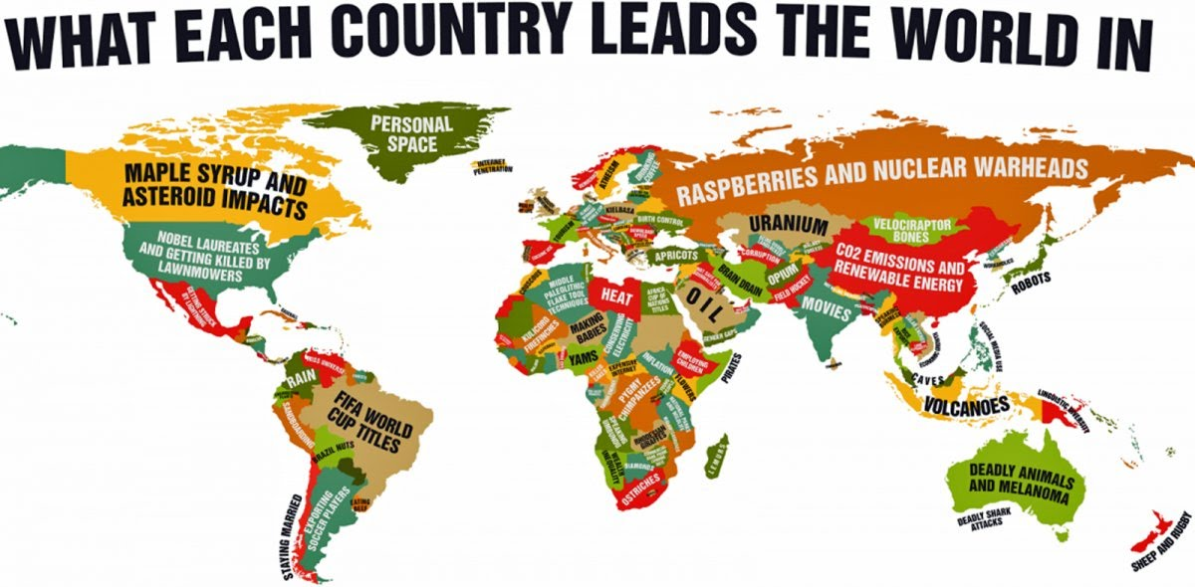

September 4

- EBs: Mastroberti, Pilkey
Lackey, Renshaw
Kellogg, Lawrence

- Lecture

September 6

TEST

