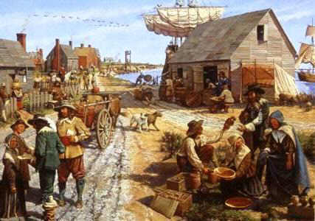
Agendas APUSH
September 9-13, 2019

September 9
- Review Period 2
- Study the Thesis Machine PowerPoint
- Complete the Thesis Machine worksheet using an assigned long essay

September 10
- Each student will read one of five essays concerning the ways history classes portray slavery.
- The students will then walk around the room, sharing their findings with two other classmates who read other essay. They will discuss the thesis, arguments, and evidence found in the essay they read.
The class will debrief on the five essays as a whole

September 11
Video: America: The Story of Us/Rebels

September 12
- Quiz: Zinn People of a Mean and Vile Condition
- Fishbowl
- Lecture

September 13
Students will complete a long essay (LEQ.) They will be able to use notes, books, and rubrics.

