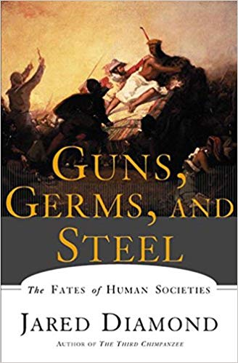
Agendas
APHUG
Sept. 10 & 12, 2019

September 10
- AMSCO 2 Quiz
- Discuss Chapter
- Rosling Quiz

September 12
- Map Game
- Guns. Germs, and Steel, Episode 1

