Paul Revere’s Ride Image 1
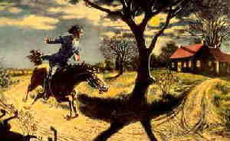

Paul Revere’s Ride Image 2
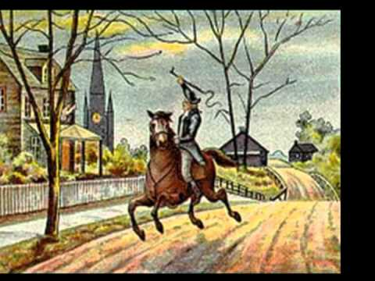

Paul Revere’s Ride Image 3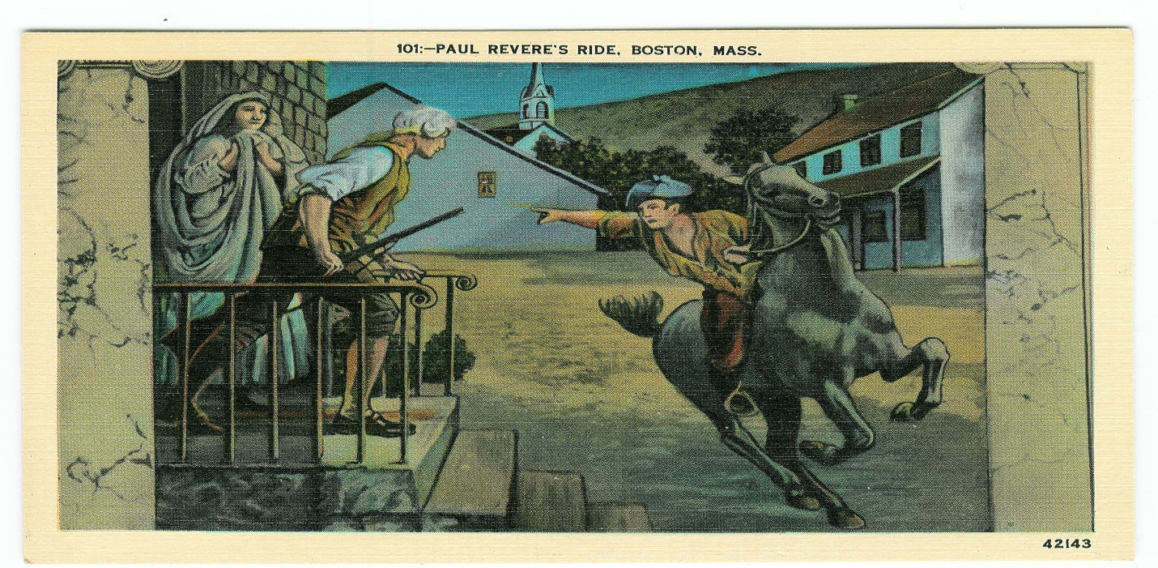

Paul Revere’s Ride Image 4

